Course link: <https://www.udemy.com/course/microsoft-bot-framework-v4-nodejs-with-real-life-example/>

**To execute the code base:**

1. **To run locally:**
2. Open Bot emulator tool on local machine and select the local .bot file in it. Configuraton of .bot file should be as below:

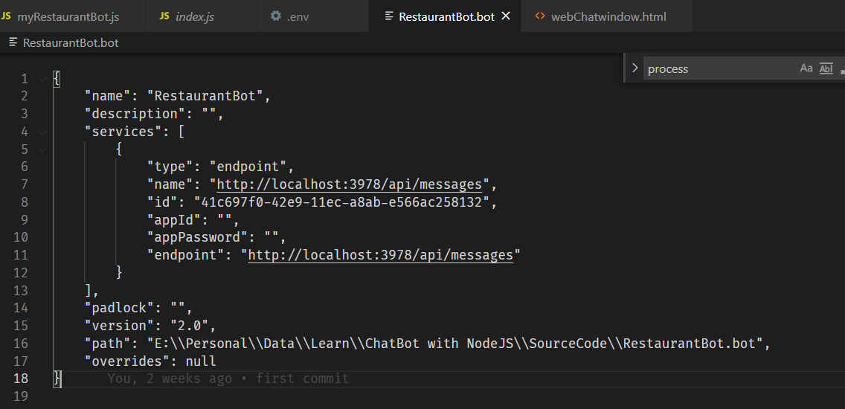

1. Remove **MicrosoftAppId** and **MicrosoftAppPassword** values from .env fileas shown belowand then run the code from VS code.

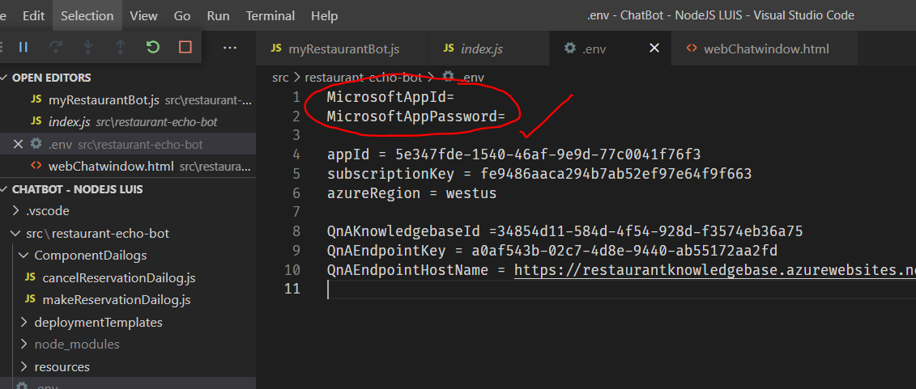

**content of file**

1e667a68-644e-4f30-ab8f-596a7af2137b

AtLeastSixteenCharacters_0

5e347fde-1540-46af-9e9d-77c0041f76f3

fe9486aaca294b7ab52ef97e64f9f663

westus

34854d11-584d-4f54-928d-f3574eb36a75

a0af543b-02c7-4d8e-9440-ab55172aa2fd

https://restaurantknowledgebase.azurewebsites.net/qnamaker

1. **To run the one hosted on Azure:**

To do this, we have not used emulator, but used the option ‘Test In Webchat’ option on azure’s bot service instance as shown below:

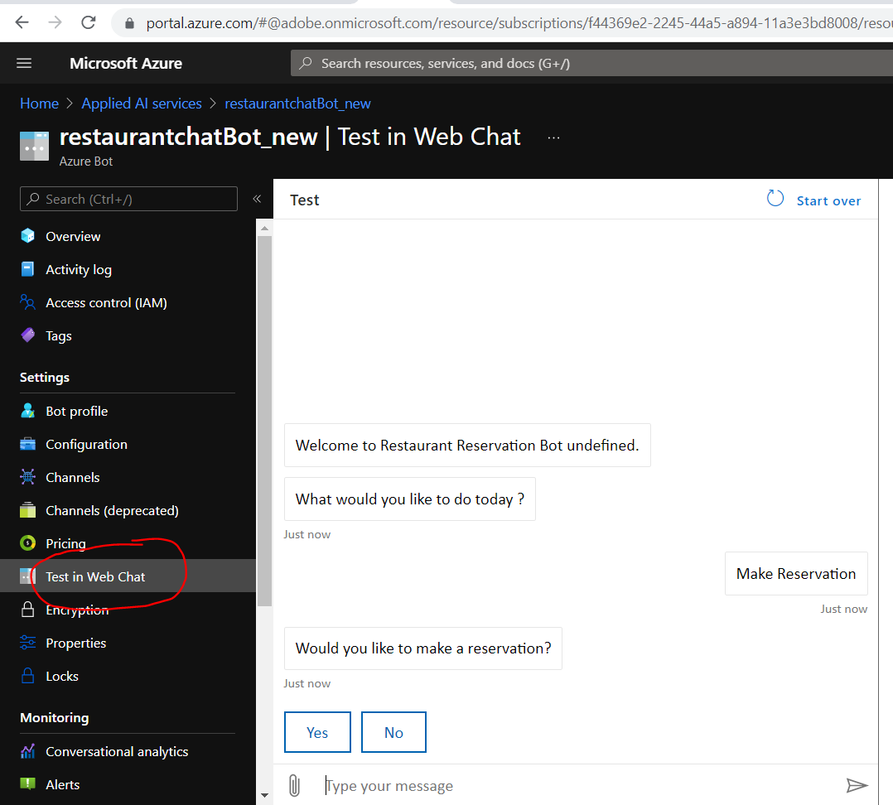

======================================================================

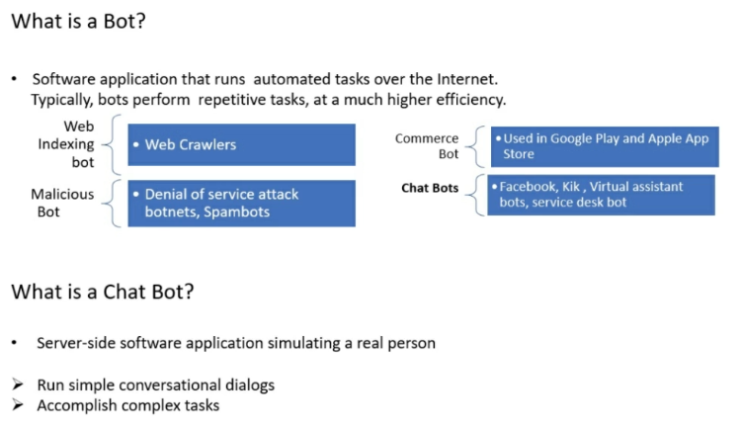

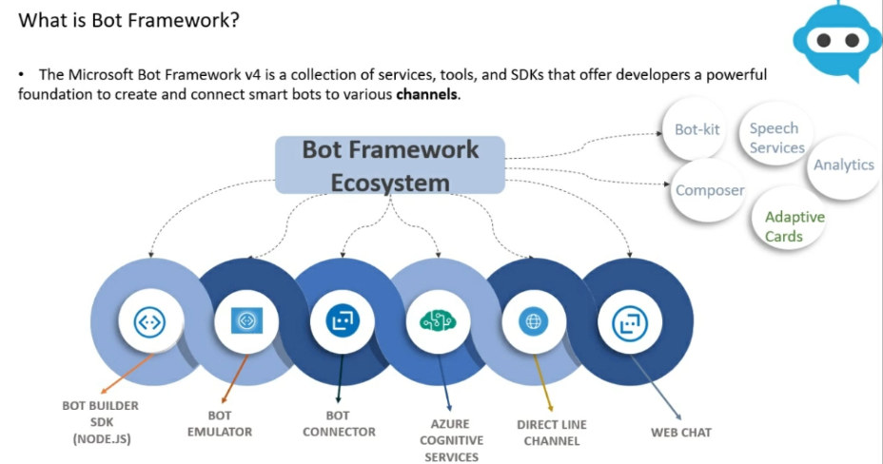

Resources required:

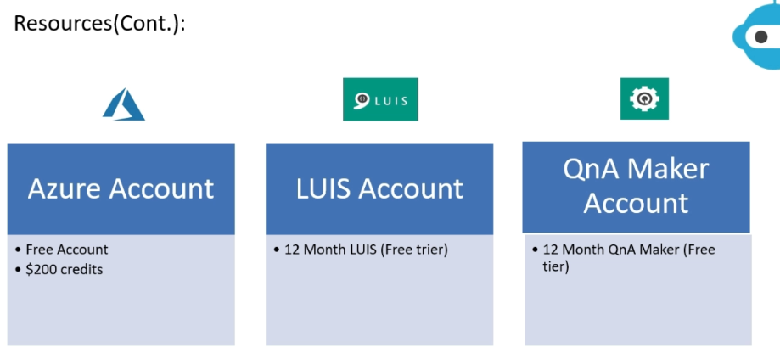

**Use case description below:**

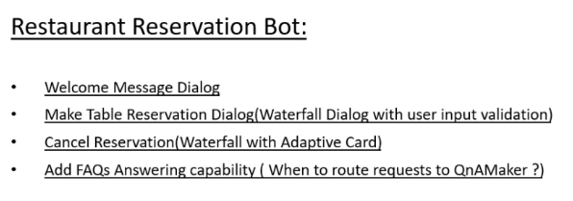

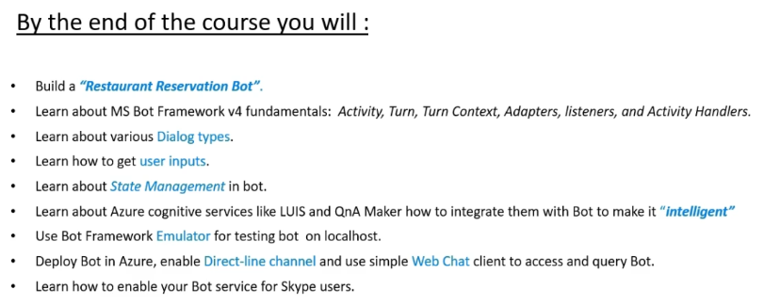

Tools required:

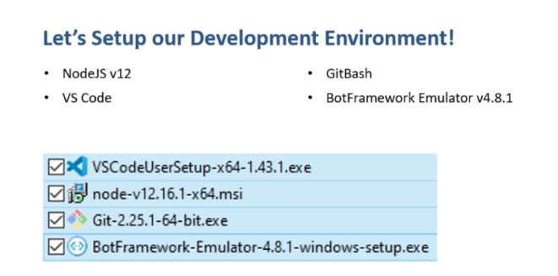

**Steps summary**

1: Create a "Language Understnding" authoring instance on Azure portal

2. Create LUIS app on LUIS portal (where we can define intents, entities etc)

3. Create a QnA instance on Azure portal(Knwledge base, which will expose an endpoint URL).

4. Next on QnA.io portal we create a actual KB where we define our Quesitons and Answeers

5. Next we create a Bot via 'yo' and 'generator-botbuilder'

After installation run command : 'yo botbuilder'

This will create a Node based Bot solution (Boilerplate)

6. To work with dailogs you need **botbuilder-dialogs** pn package

npm i botbuilder-dialogs

7. We use <http://LUIS.ai> for NLP

8. To use **LUIS NLP API , we use botbuilder-ai** module. We create Intents, Entities, Phrase list using LUIS

npm install botbuilder-ai

<https://www.npmjs.com/package/botbuilder-ai/v/4.1.7>

Check all package versions below:

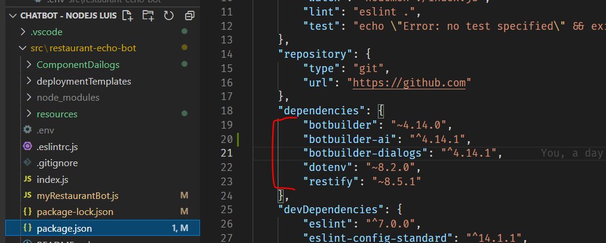

9. We use <https://www.qnamaker.ai/> for building QnA for the bot

As a first step: In Azure Go to “Language Understanding” and create a new instance:

Herre we are creating a LUIS app on Azure

Language understanding (LUIS) is a natural language processing service that enables you to build your own custom model to understand human language programmatically **or through the UI in the LUIS portal**. After you are satisfied with your LUIS model, you publish it and query it's prediction endpoint through your client application for an end to end conversational flow. **To build, manage, train, test and publish your LUIS Model, you will need to create the below Authoring Resource**. This also gives you 1,000 requests/month endpoint requests. If you want your client app to request **beyond the 1,000 requests provided by the authoring, create the below Prediction Resource**. If you know from the start you will be needing more than 1000 prediction requests as well as the authoring experience, create using the "Both" option. This will create two resources, one for each type.

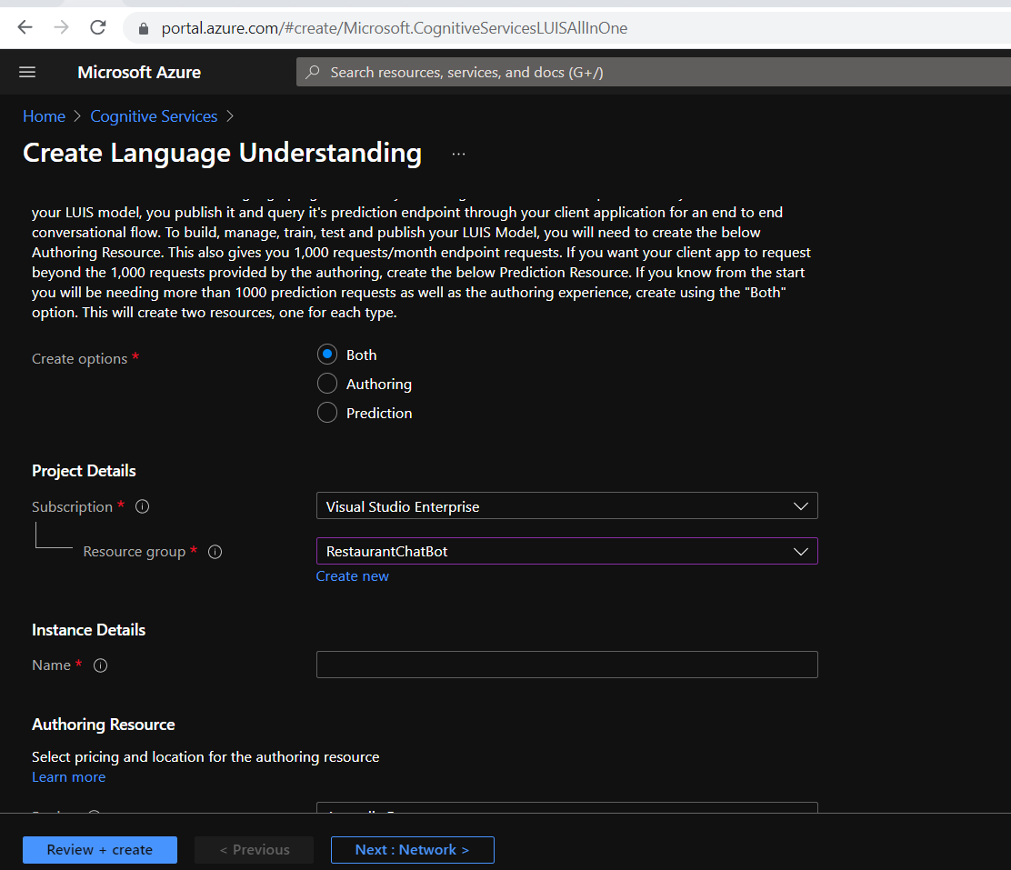

Once app is created, we can use its keys:

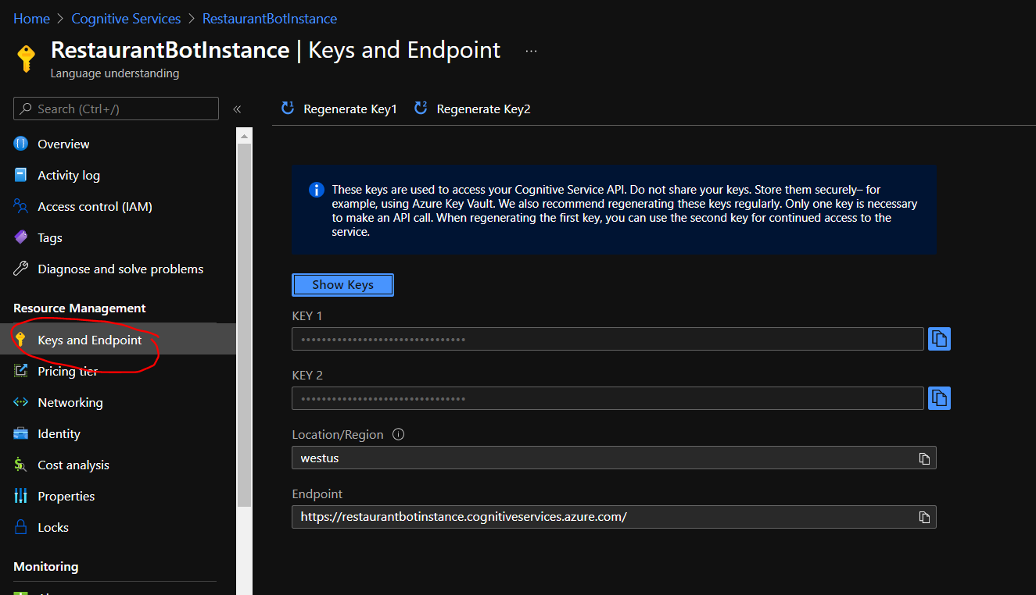

LUIS has a separate portal too - <https://www.luis.ai/>

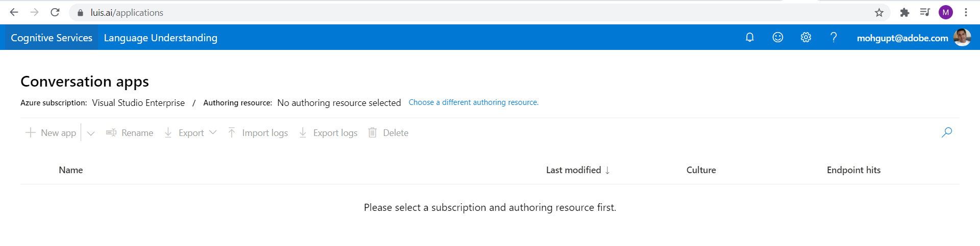

Creating a new LUIS app on LUIS portal:

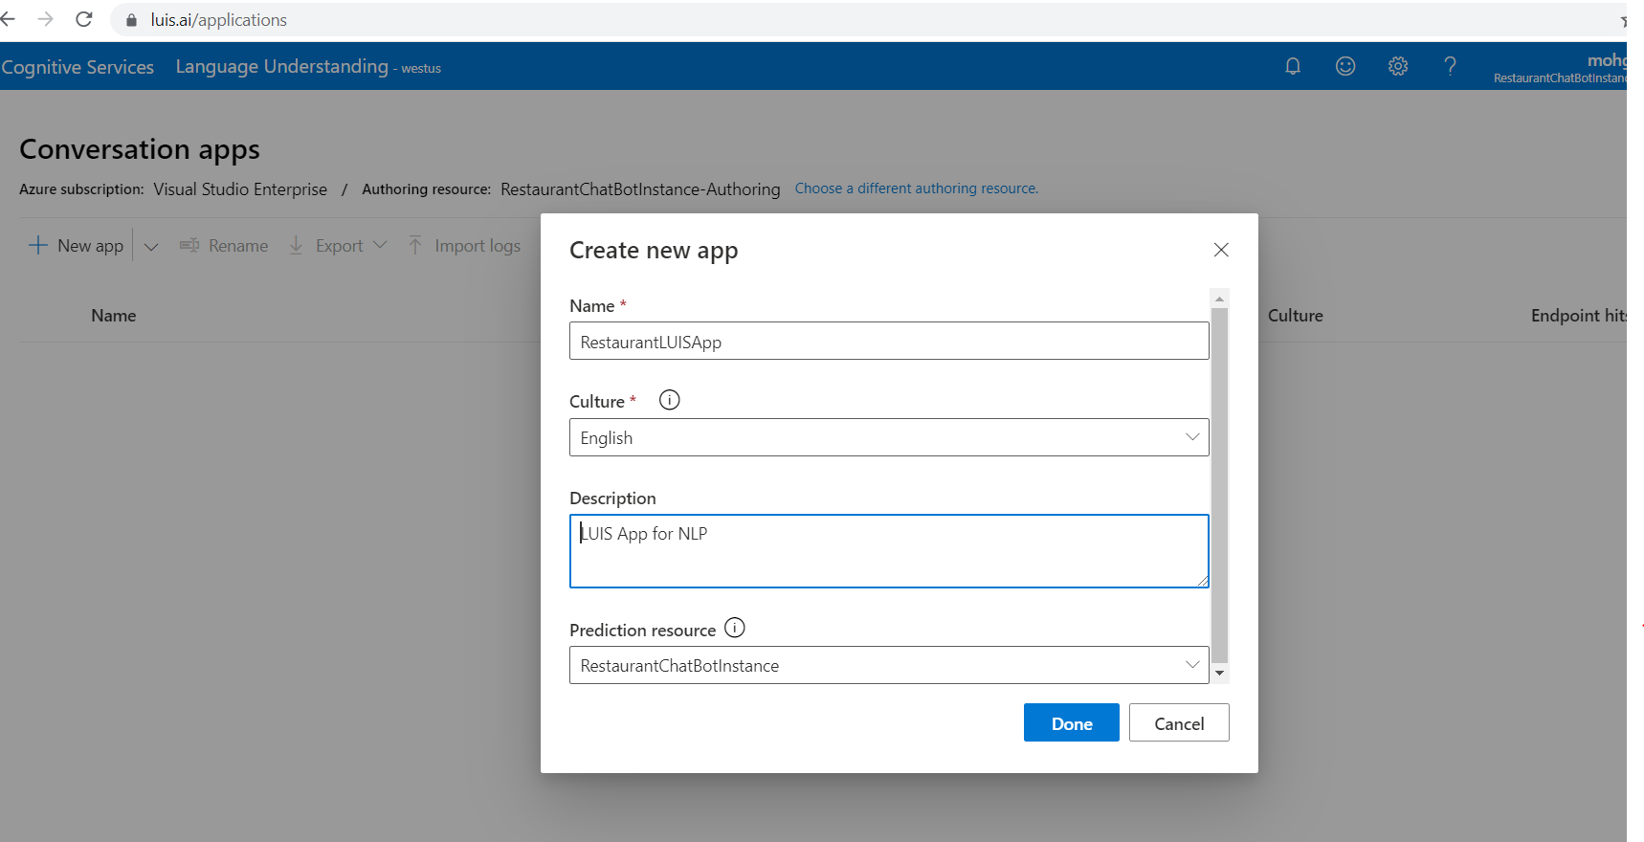

Above one is the app created on LUIS portal (NOT azure portal). Here you will define Intents, Entities which are used to create NLP Model.

Prediction resource created on Azure portal will reflect here in LUIS portal automatically. Choose the same Prediction resource created earlier while creating LUIS instance on Azure portal

* **Guidline to create LUIS model below:**

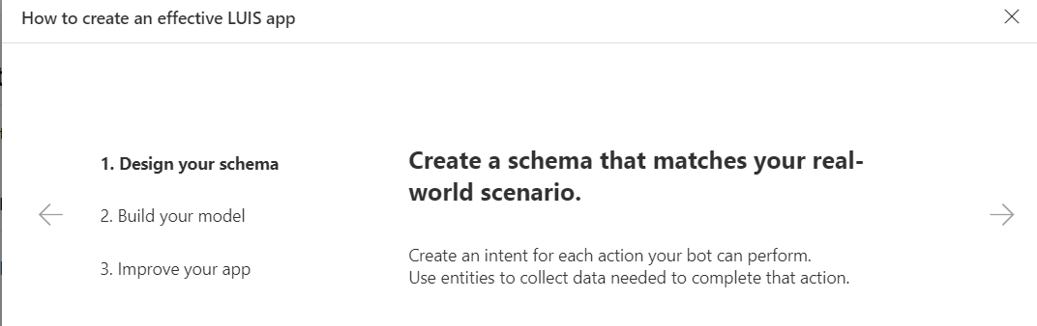

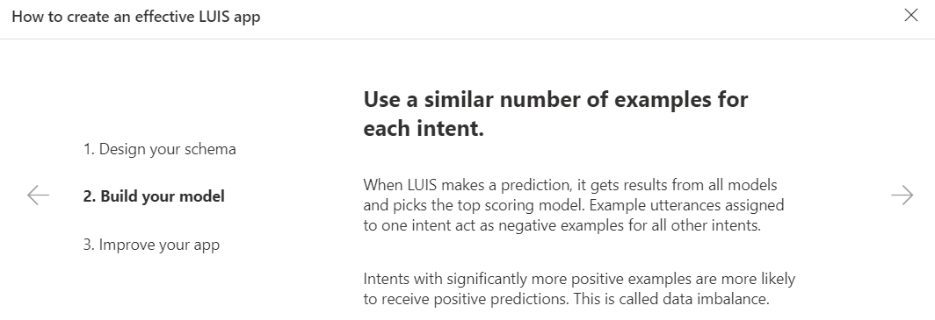

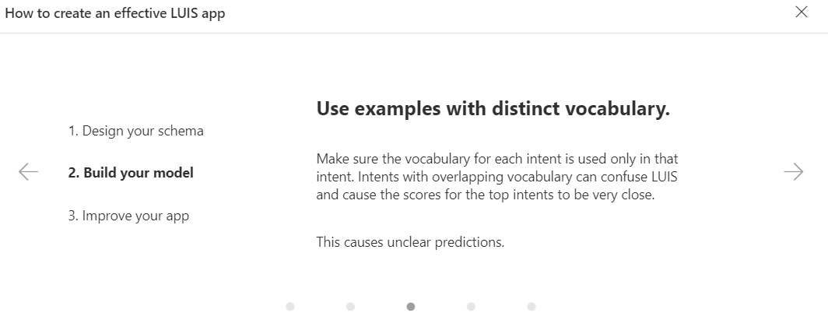

* Now after creating LUIS service on LUIS portal, we will now **create QnA maker** **service** on Azure portal

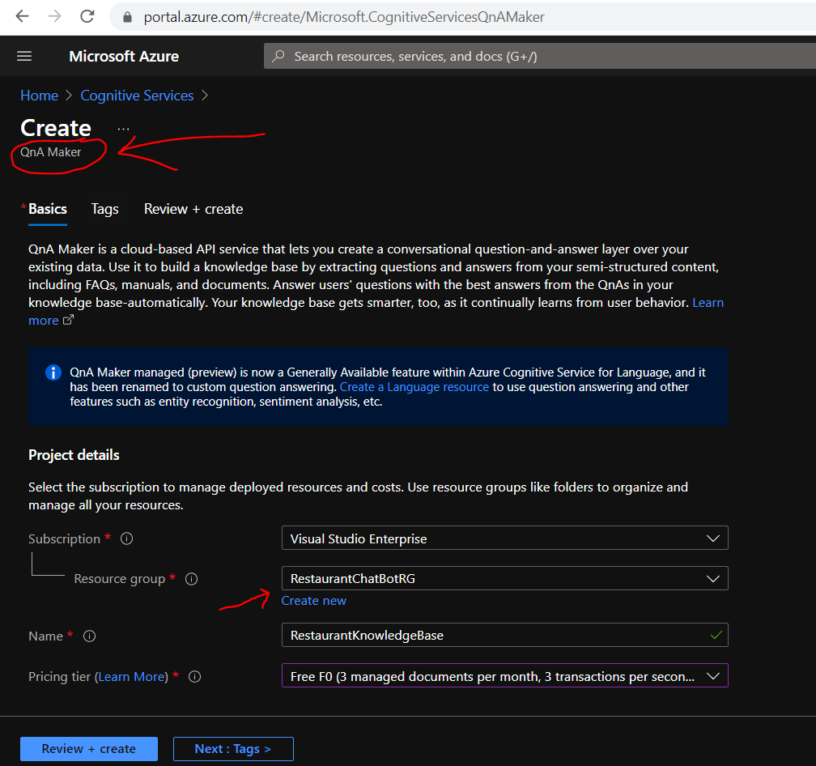

We are creating a QnA maker. Notice we are using the same Resource grp here.

Once created it will expose an API end point and keys to access

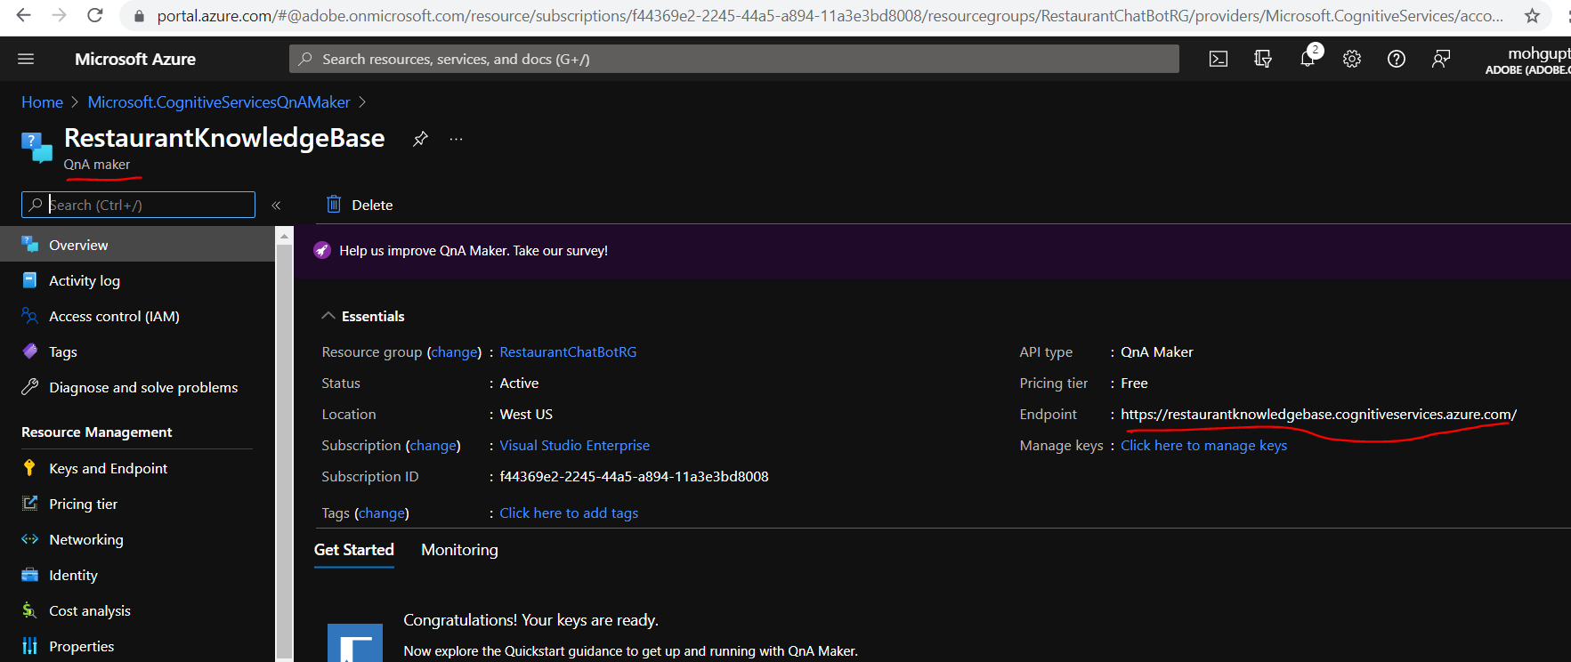

Now go to : <https://www.qnamaker.ai/> and sign in

On selecting the subscription, this portal will reflect the Knowledge Base created earlier on Azure portal

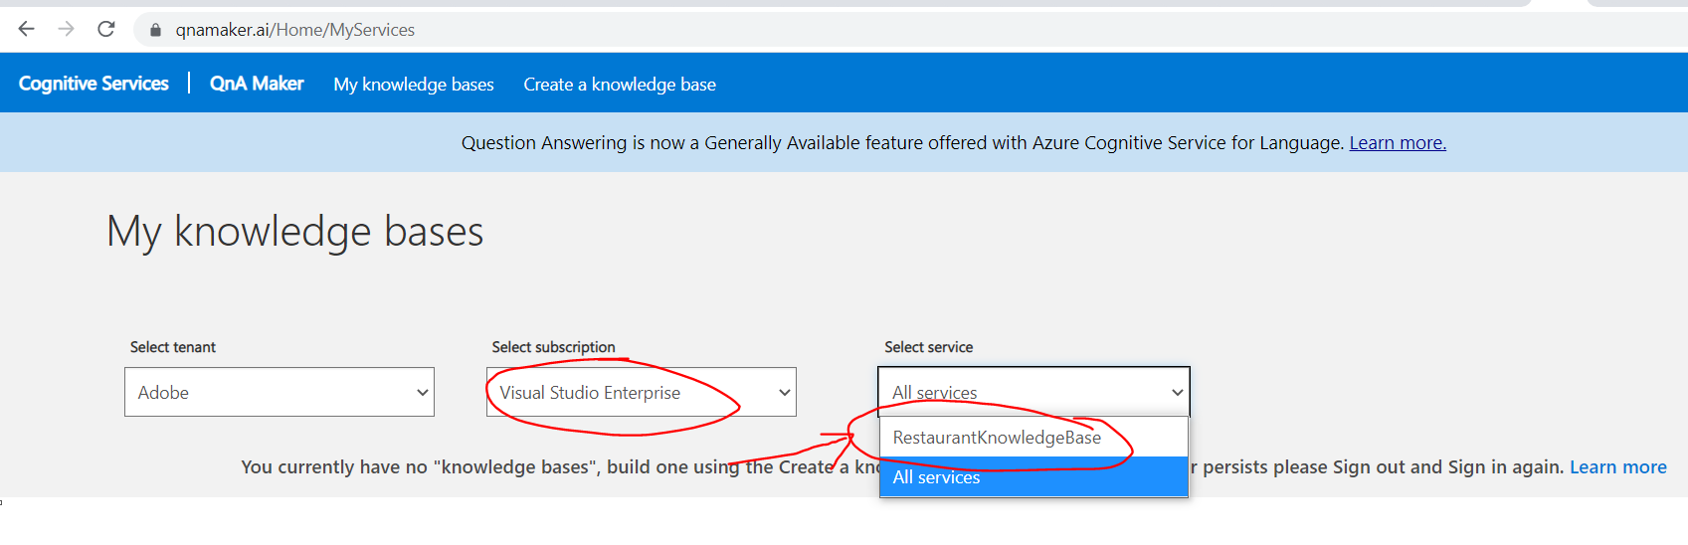

Below are the steps on <https://www.qnamaker.ai/> to create a Knowledge base

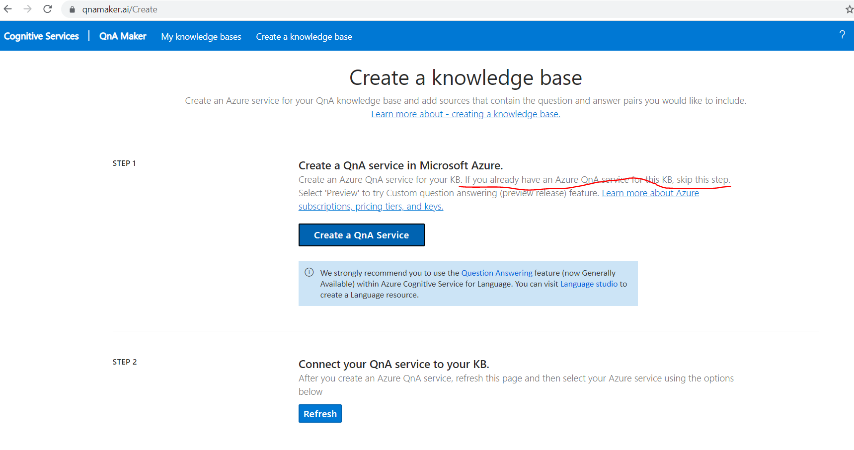

Since we have already created a QnA service on Azure portal, we will skip Step 1

Now in Step 3, it will ask for Knowledge Base name you want to keep and also will to **populate the KB.**

**For sample,** You can use Google policy link: [**https://policies.google.com/faq**](https://policies.google.com/faq)as **shown below:**

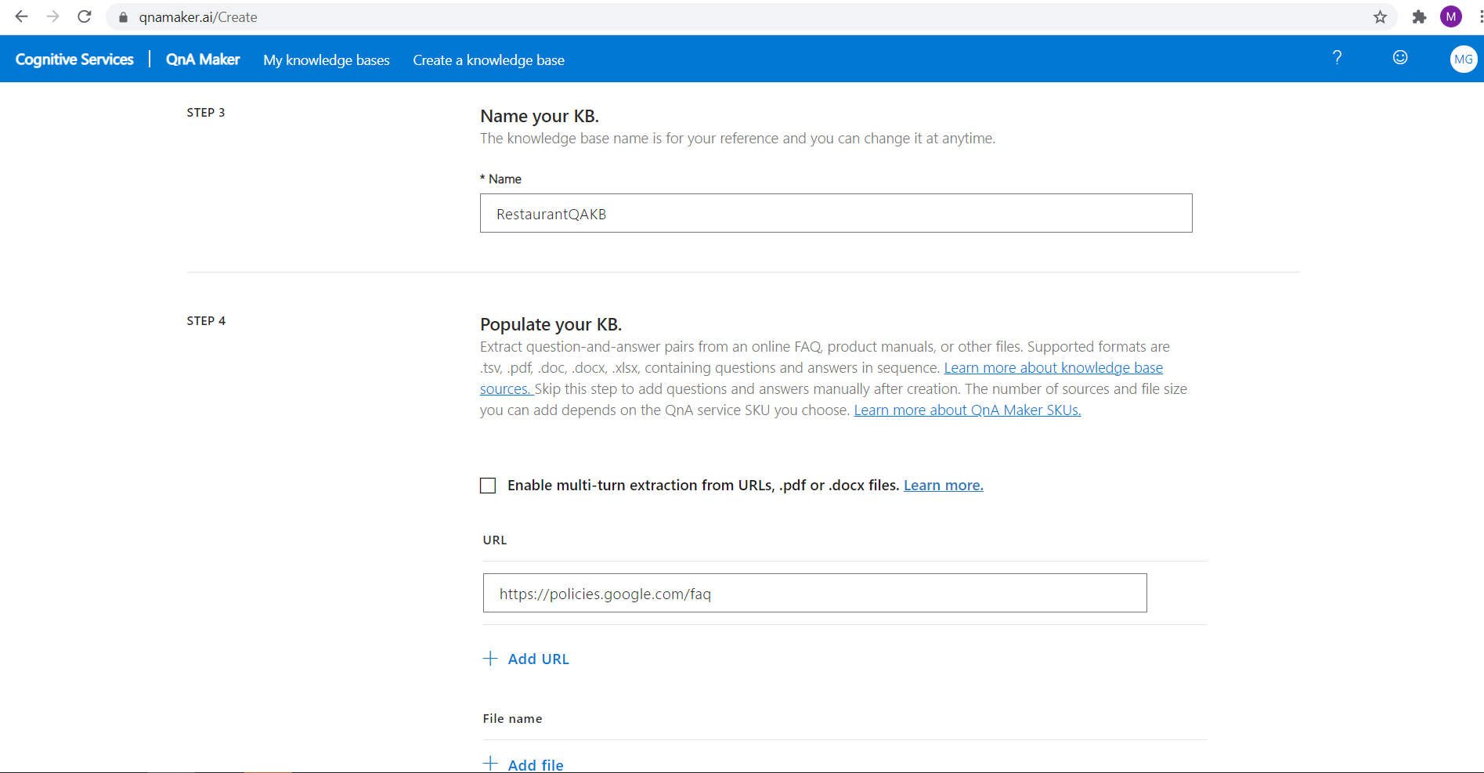

Nest you create your KB (Knowledge base). Final screen looks like below:

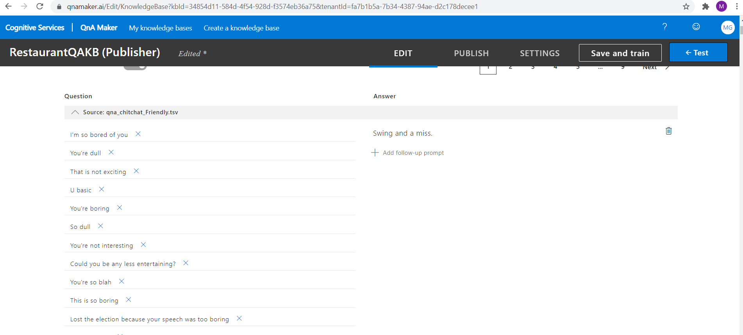

Next press “**Save and train**” button

You can add more QnA from the Edit page as shown below:

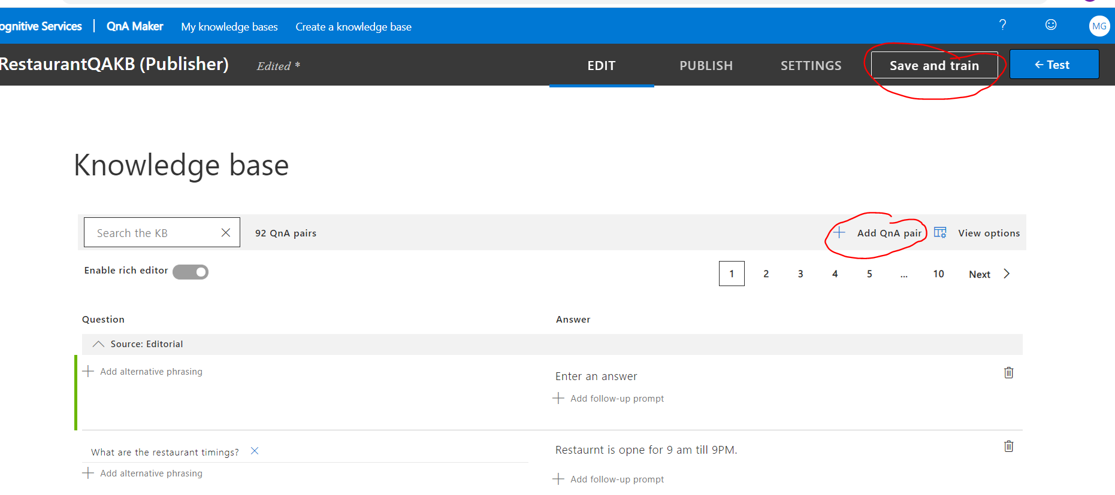

Now you can test the QnA

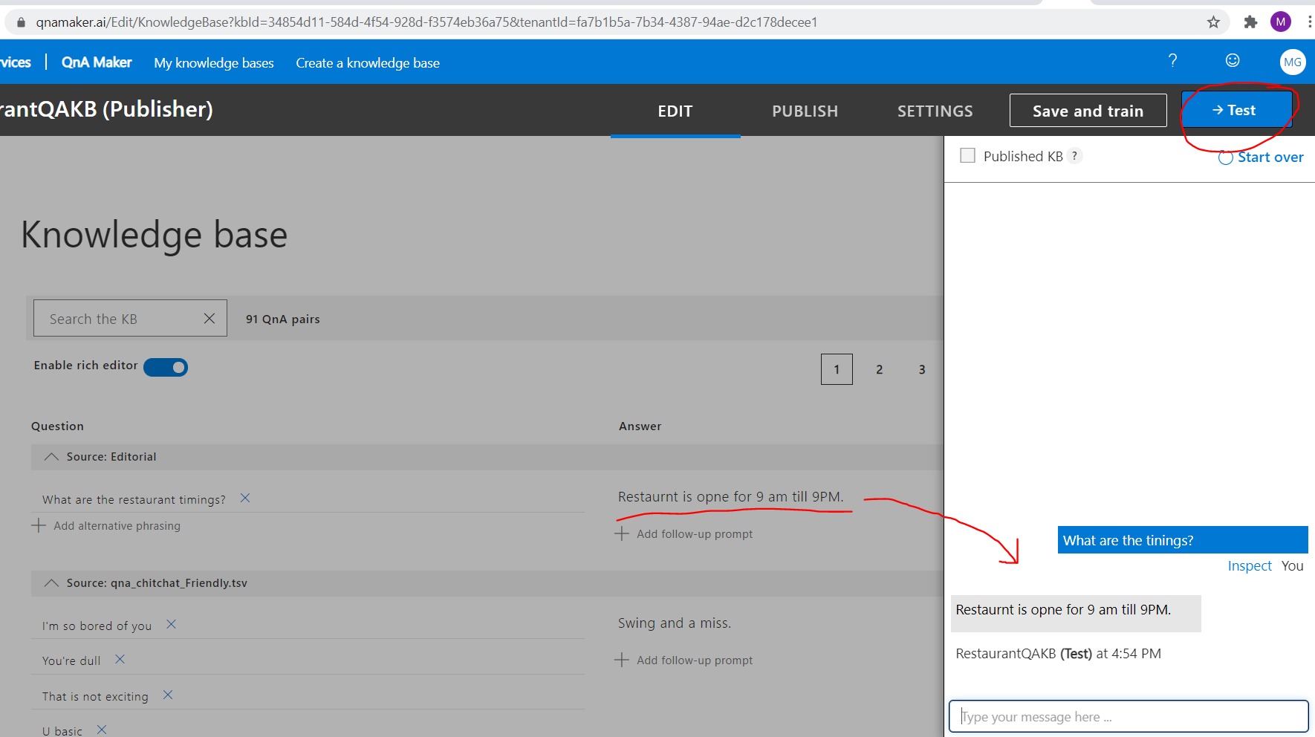

Next you can Publish - once you publish the KB, in  **settings**  it will give you an endpoint to use to use Knowledge base. See below:

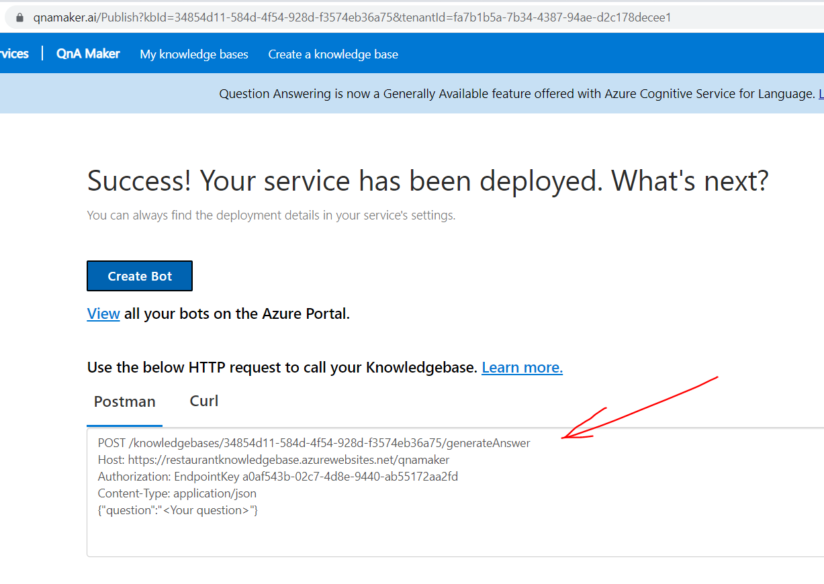

We have got the endpoint on publishing.

**Azure Bot Service**- Tools and Services which helps in interating the different components provided by Bot framework to test, build and manage your bot.

Bot service Procvides quick start templates to start building Bots quickly. Also provides template for

1. Cognitive service like LUIS and QnA maker
2. To deploy Bot to Azure

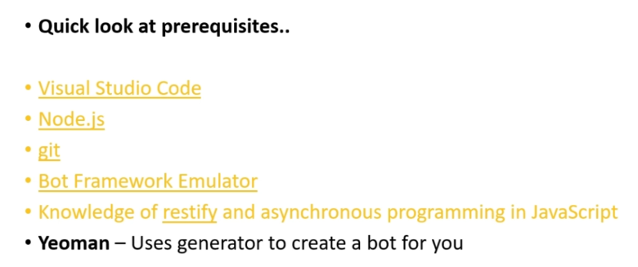 We will be using Yeoman

**Creating EchoBot**

Step 1:We will install ‘yo’ and ‘generator-botbuilder’ via npm

<https://www.npmjs.com/package/generator-botbuilder>

Step 2: Use the botbuilder to create a new Echo Bot

Command: **yo botbuilder**

It will create a folder which will have entire code for Bot and deployment templates too that you can directly use in Azure as shown below:

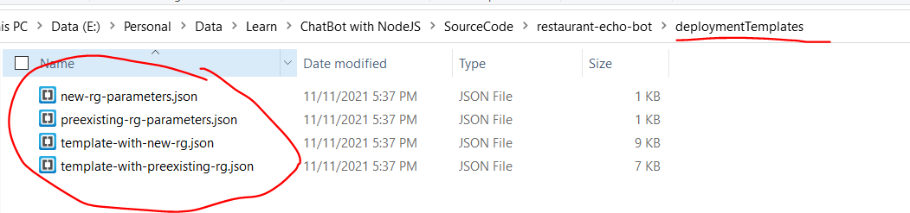

Now to run the bot solution you can run command :  **npm run start**  from the root of the new directly if above created bot

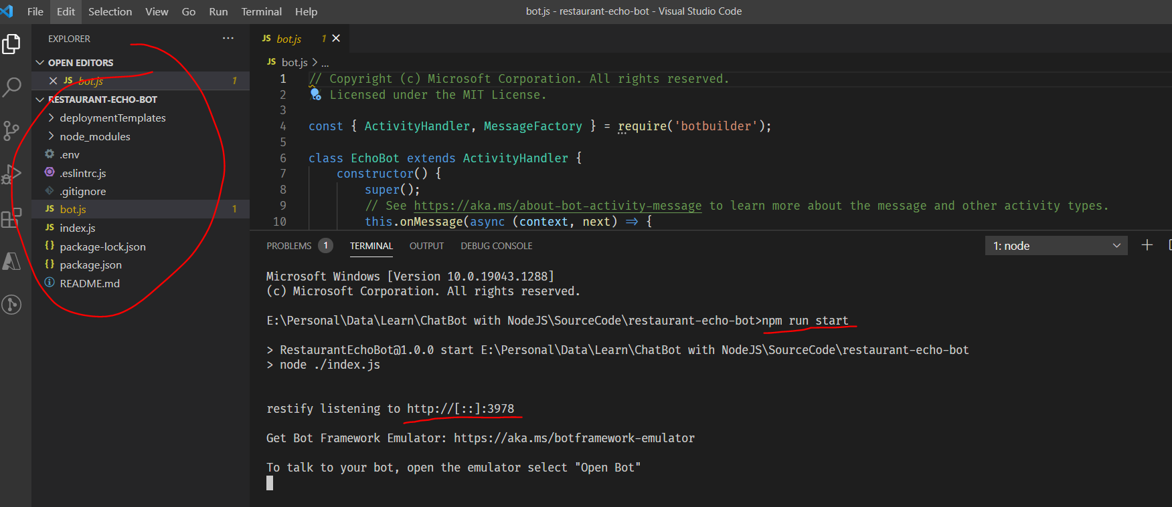

Now go to Bot Emulator (installed previosuly)

And create a new bot configuration as shown below:

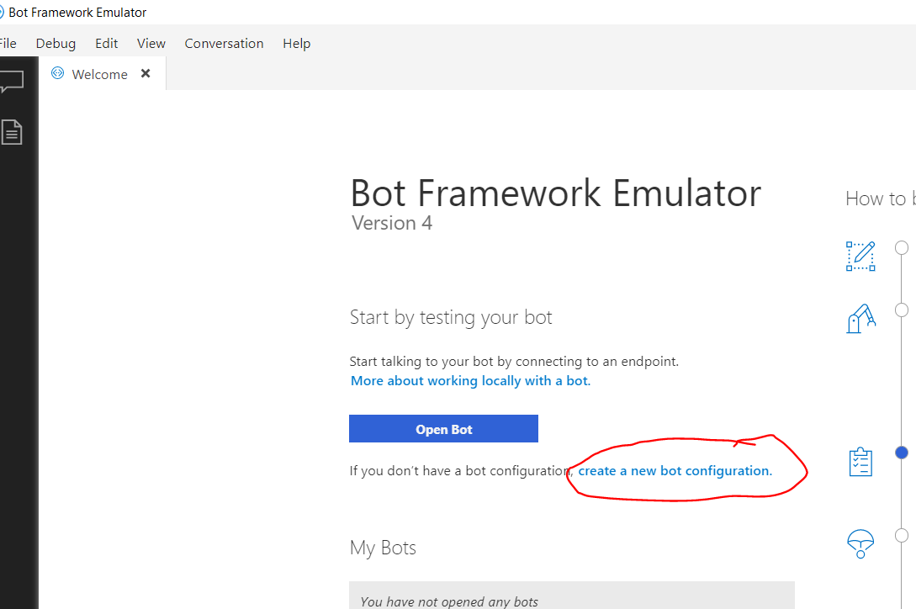

In the configuration window, give any name to the bot and in the URL, use the same port as it was displayed in the above screen when we run the source code i.e. 3978 with a default route of **api/messages/**  as shown below.

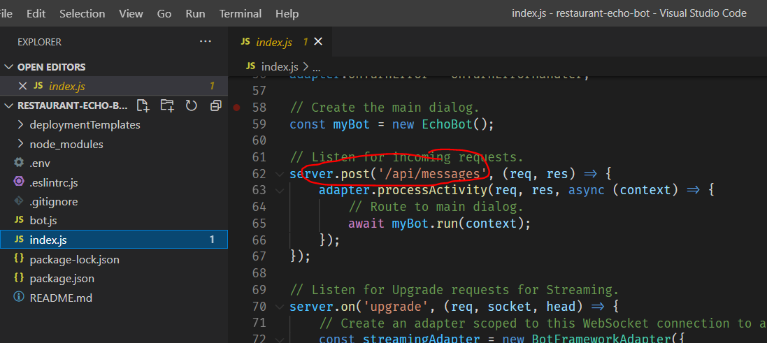

If your bot is hosted on Azure provide Azure UserId and Pasword:

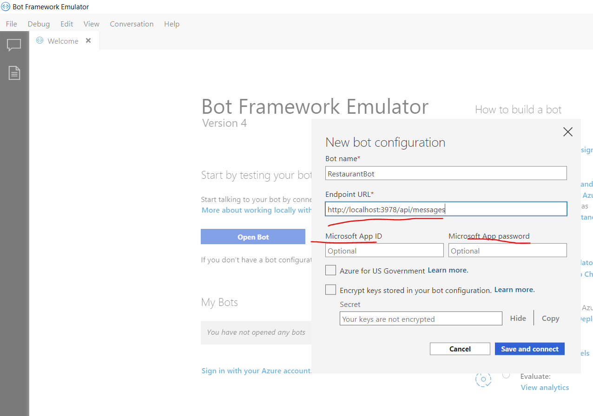

Above file will give you a configuration file(**\*.bot**) which you can resuse.

One configuration file is set and saved, it will apear automatically in Emulator Home page like below:

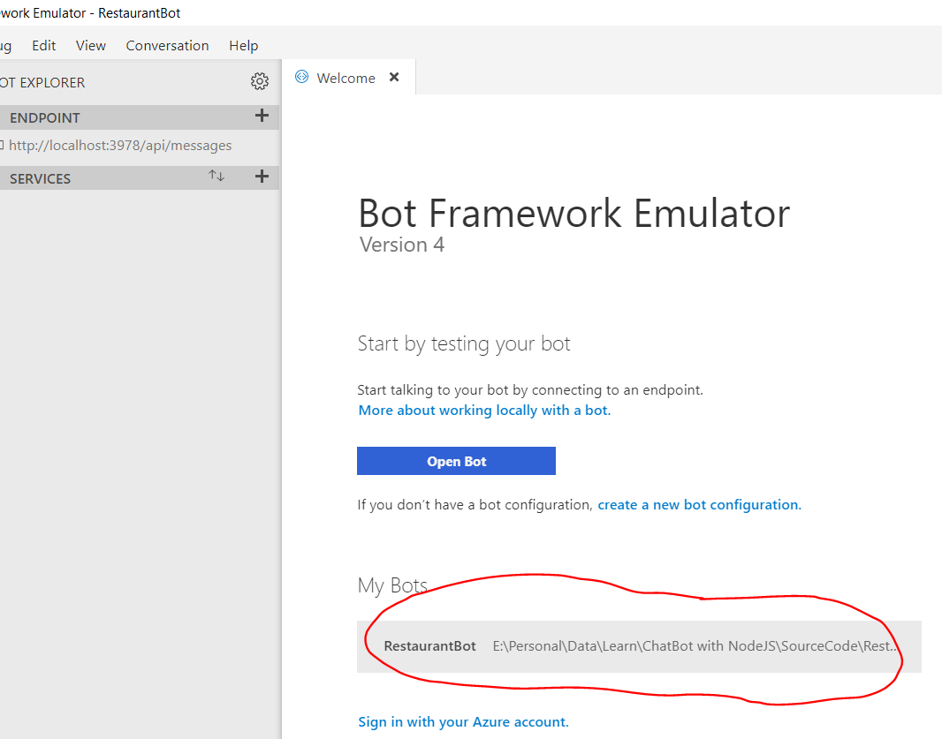

**Our Echo bot is ready.**  Echoing the same message what we are typing

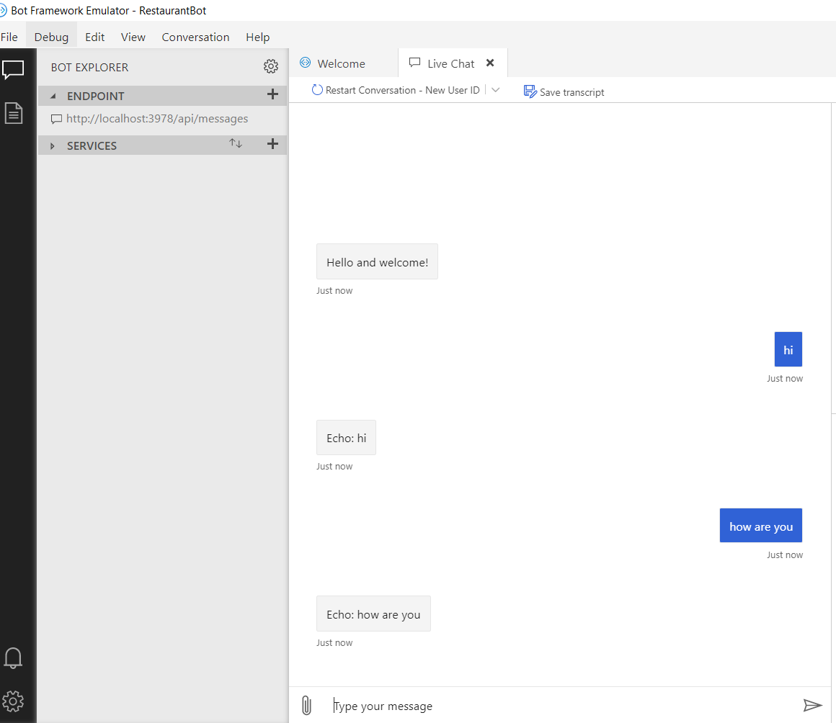

* **Bot Terminologies**

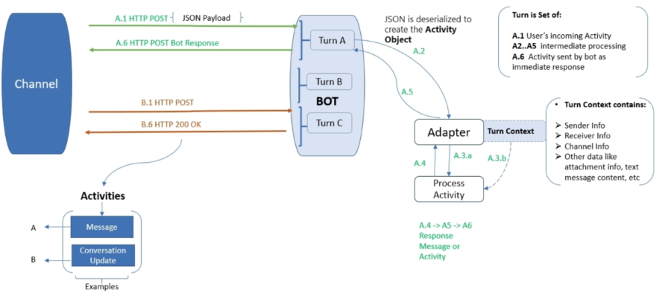

**Channels-** like WebChat, facebook messagner, Skype, etc.

**Activity** can be text message, speech message, attachment, etc

**How it works**

Activity’s json payload is received by Bot which runs a **restify** **web server**(npm package in Node solution). **Restify deserailizes the JSON payload** and send the deserialized payload to **Adapter**. See how adaptor is used in Node solution.

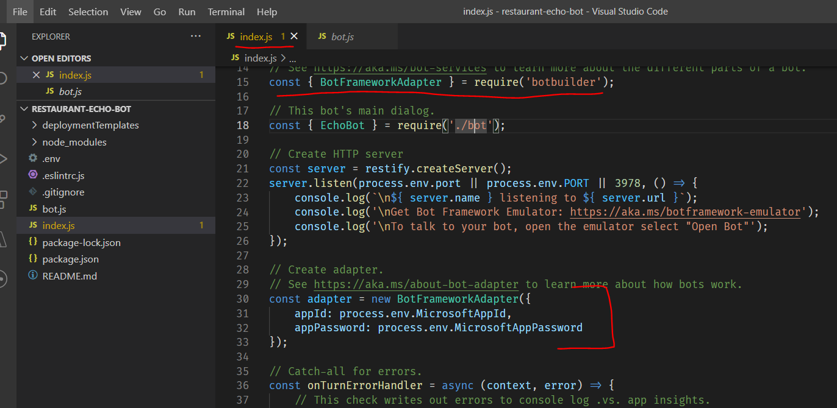

Adaptor will than process the payload (by calling ‘processActivity’ method of adapter) and that creates a ‘**Turn Context’**out of it and than sends this activity to **ActivityHandler.** See picture below. **ActivityHandler** is our

Bot which will then call Main Dailog’s run method (Main Dialog is the Bot object in our case). This Bot object extends ‘ActivityHanlder’ class. See picture below

**Turn Context** gives the information like ‘Sender Info’, ‘Receiver Info’, Channel Info to the bot. Bot needs to know where the info is coming from and where it needs sent the respond to , etc.

Turn is just ow people talk to each other to make his/her own argument. E.g. in above diagram A1-A6 is turn

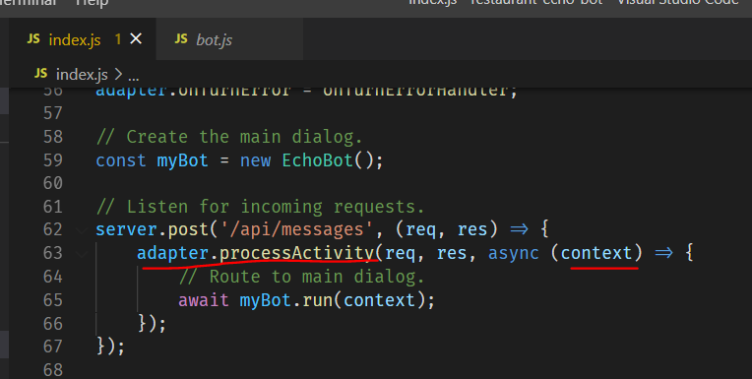

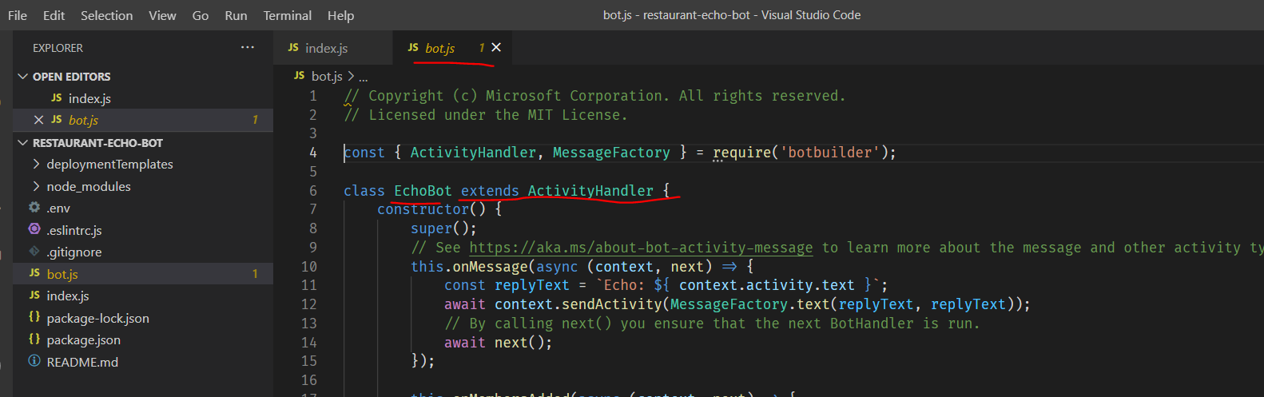

Actvity Handler is a class provided by Bot Builder and uses an EventEmitter and listener pattern. E,g. onMessage() to register an event listener for a message type activity.

All activity types are listed here:

<https://docs.microsoft.com/en-us/azure/bot-service/bot-activity-handler-concept?view=azure-bot-service-4.0&tabs=csharp>

* **Understanding ActiivtyHandler**

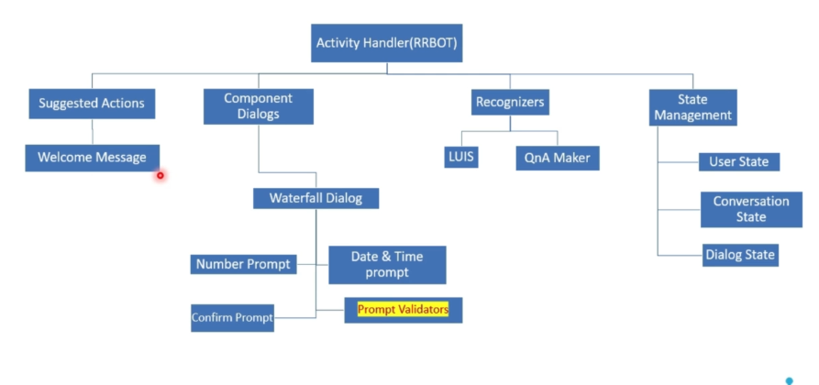

Now we first modiify MemberAdded activity type method in bot class to change the welcome message and also send some **suggestedActions** as shown below:

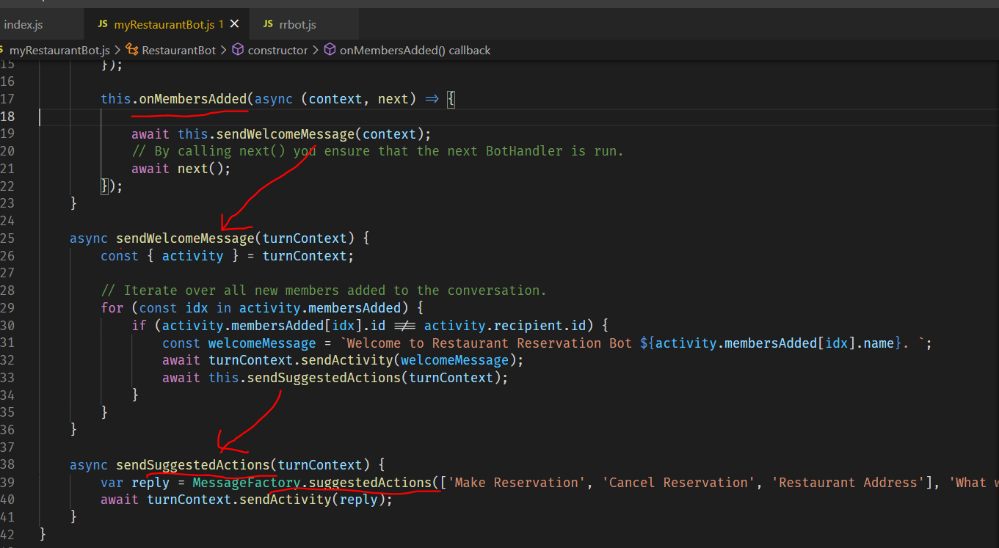

**OnMembersAdded** is called when the chat window is first opened.See how it looks in action in emulator below:

**Check above in code base**

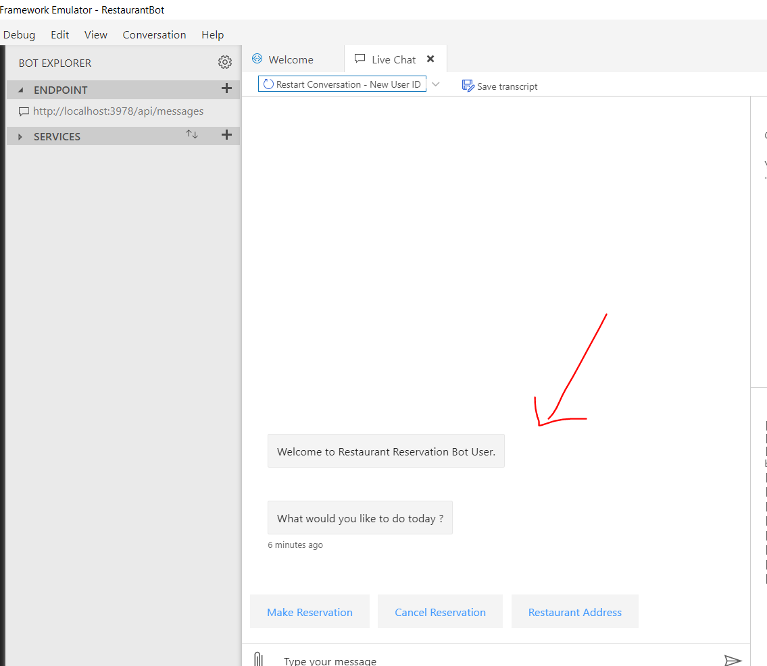

Notice that the username is coming as ‘User’ and it can be checked, it is coming from Activity JSON in Emulator Window as shown below:

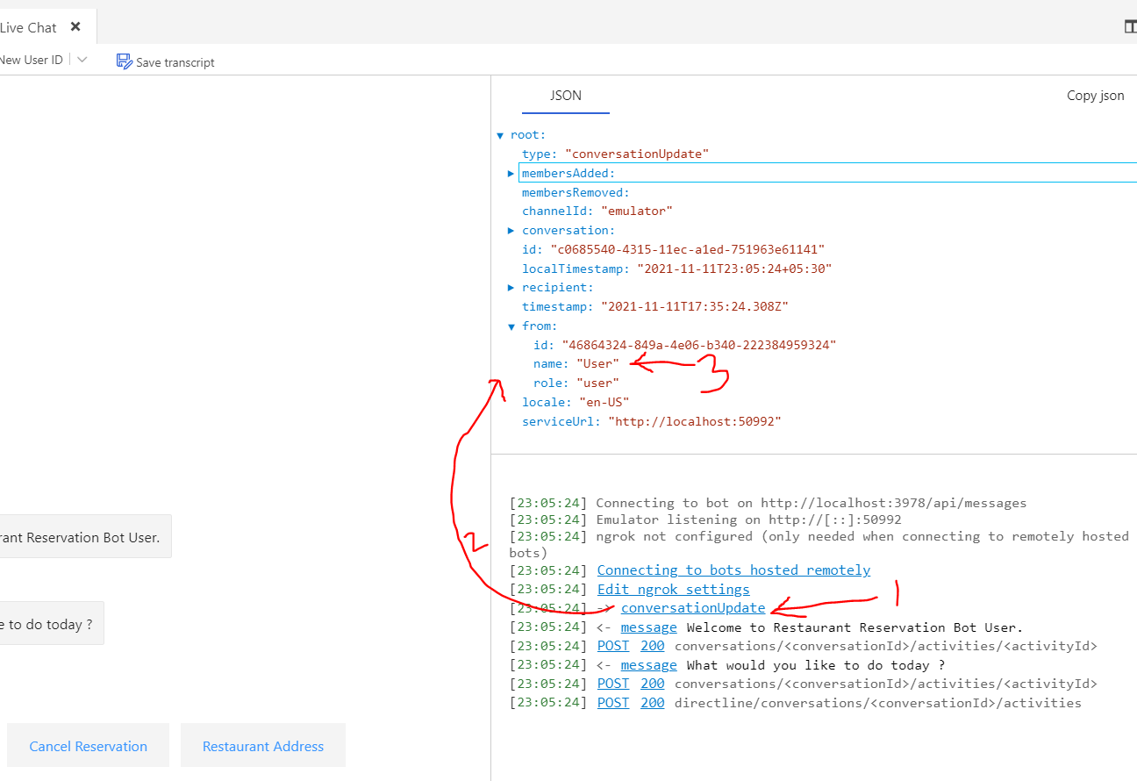

* **Types of Dialogs**

We have a few different dialogs: **Prompts**, **Waterfall dialogs**and**Component dialogs**

**Prompts**

Prompts are used to ask the user for input and wait until the user enters input.

There are different prompts available, and among those:

* Choice Prompt: Asks for a choice from a set of options
* Text prompt: Asks for general text input
* Confirm prompt: Asks for a confirmation.
* Number prompt: Asks for a number.
* OAuth Prompt: Asks the user to sign in using the Bot Frameworks Single Sign On (SSO) service

**Waterfall dialogs**

A waterfall dialog is composed of a sequence of steps. Each step of the conversation is implemented as an asynchronous function that takes a waterfall step context parameter. Usually, in each step, we prompt the user for input(for instance a question), which then the user can respond to.

**Component dialogs**

ComponentDialogs are containers that encapsulate multiple sub-dialogs, but can be invoked like normal dialogs. This is useful for re-usable dialogs, or creating multiple dialogs with similarly named sub-dialogs that would otherwise collide. A **component** could be added as a **dialog** to another **ComponentDialog** or **DialogSet**.

**What is a Dialog Set**

DialogSet is a container for multiple dialogs. Once added to a DialogSet, dialogs can be called and interlinked.

* **Working with Component Dialogs**

We are going to create a Reservation dialogue next which will be Component Dialog.

Waterfall dialog is a type of Componnet Dialog

Our Waterfall dialog will contain a number of stepswhich will run in a sequence when the dialog is triggered and each step will contain some prompt. We are going to use a number prompt, text prompt and a confirmation prompt. Than we will also validate our prompt. We will take one example of number prompt and than try to validate the value entered by the user if the value entered by the user is in a particular range.

* To work with dailogs you need **botbuilder-dialogs** npm package

npm i botbuilder-dialogs

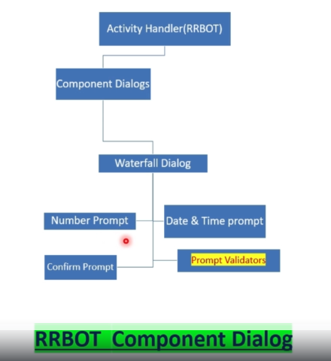

**Dialogs are key concepts in Bot Framework SDK** and is provided by **botBuilder-dialog** module

Dialogs can be thought of as structures in your bot that can act as function in your Bot’s program and each dialog is designed to perfrm a specific task.In this case we are going to make reservation for a user.

There can be many dialogs and you can specfy the order of dialogs to guide the conversation and you can invoke them in different ways.

* **How Dialog States are stored**

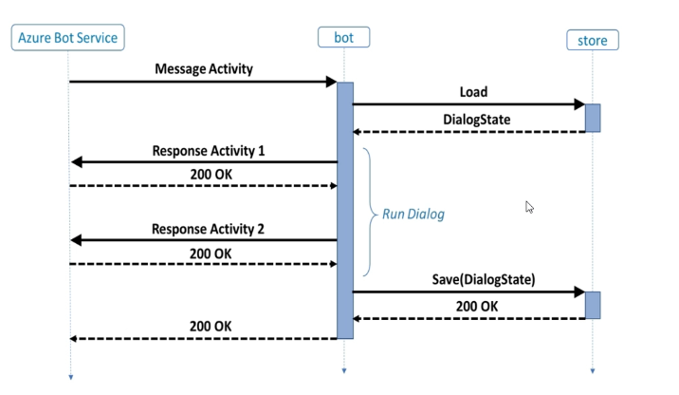

When messageActivity lands on our bot from Azure Bot service, the bot will check our Storage layer for already saved DialogState for that particlar conversation and if a Dialog Stateis present it will be sent to the Bot and than process the content as per the content of Dialog State which was saved from the previous step.

InMemory is not recommended for Production since this type of Stprage is volatile and has limitation of **32KB of data.**

* **Making Hotel Reservation Bot**

**Step 1: Index.ts file changes**

* For in-memory, we have added **MemoryStorage class** in Index.js file

const { BotFrameworkAdapter, MemoryStorage } = require('botbuilder');

const memoryStorage = new MemoryStorage();

We also add **ConversationState** and **UserState** in **Index.ts** file

const { BotFrameworkAdapter, MemoryStorage, ConversationState, UserState } = require('botbuilder');

**Why User and Conversation State?**

Without ConversationState, bot wont know what to do when a new activity comes in. When a user sends in message, our dialog wont know what to do, where to send that message and how to process without a Conversation State.

* Then we create objects of all 3 in **Index.ts** file only as shown below:

const memoryStorage = new MemoryStorage();

const conversationState = new ConversationState(memoryStorage);

const userState = new UserState(memoryStorage);

* Now we pass them to mainBot in index.ts file:

// Create the main dialog.

const restaurantBot = new RestaurantBot(conversationState, userState);

**Step 2: Bot File code** (Code is explained via comments in Bot file (myRestaurantBot.js), so refer it)

Here we created propertyAccessors(named ‘dialogState’) and then in onMessage() handler we handled the routing logic(which Dialog to be invoked based on the incomng message)

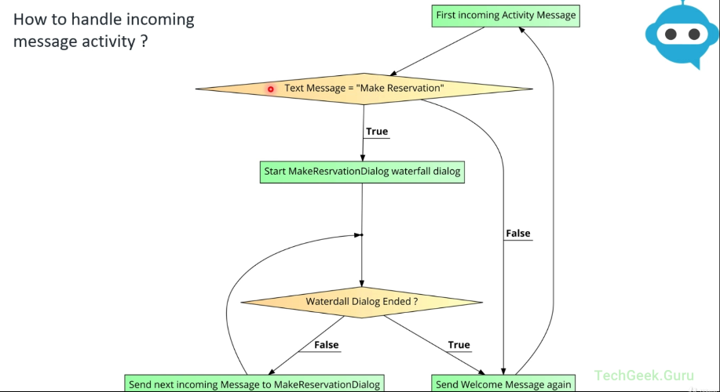

We are going to present a Welcome Dialog to the user and user joins the conversation, If user selects ”Make Reservation” , then we will start MakeReservation Waterfall dialog and user will redirected to it.If the waterfall dialog has ended than again welcome message will be displayed and this goes in a loop.

**Important to note**

Whenever user send a message to the Bot, OnMessage() is invoked everytime and OnMessage is the place where we execute the Dialog’s run() method ( line #118 ) as well.

Dialog can have Waterfall dialog as well which will be a series of steps. To execute those steps we need to call same run() method for each step to execute.

Please note - we might have mutliple Waterfall Dialogs too so we put a switch() statement as shown below in OnMessage() method.

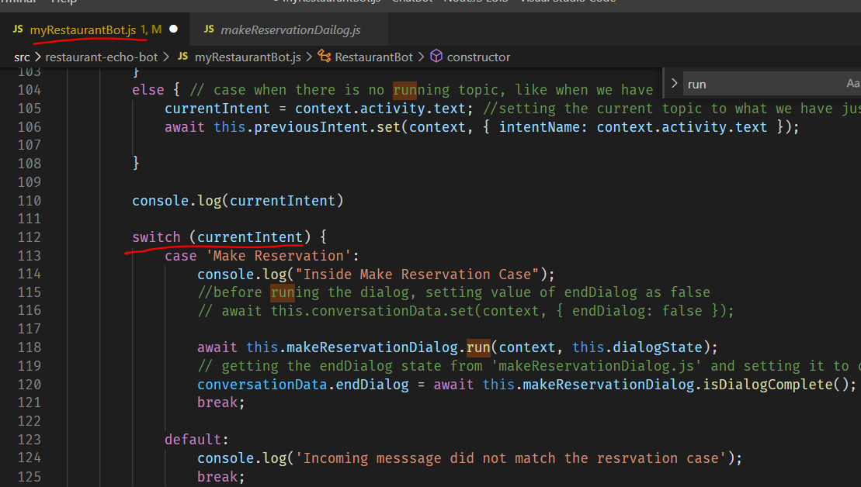

Now, for Waterfall execution we have to call run() mehtod everytime so we need a way so that run() method at line 118 executes till the Dialog has ended. So we manage this thing via local variable ‘currentIntent’ which keeps track of if the Dialog has ended.

We pull the state of diialog everytime from ReservationDialog file only at line #120. And with the help of this endDialog vaue and with few if-else statements , we set currentIntent so that run() mehotd keeps executing.

**Step 3: Added Component Dialog** (file named ‘makeReservationDailog’ in solution)

**Step 4: Adding another ComponentDialog for Cancelling reservation**

This is to understand how we can have multiple Component Dialog under one Activity handler (which is our mainDialog)

In this step we will also use **Adaptive cards**. There are multiple other cards as well as given in the link below but Adpative Cards are most versatile.

Advatnage is they are platform agnostic, You can use them MS teams, skype.etc.

<https://docs.microsoft.com/en-us/microsoftteams/platform/task-modules-and-cards/cards/cards-reference>

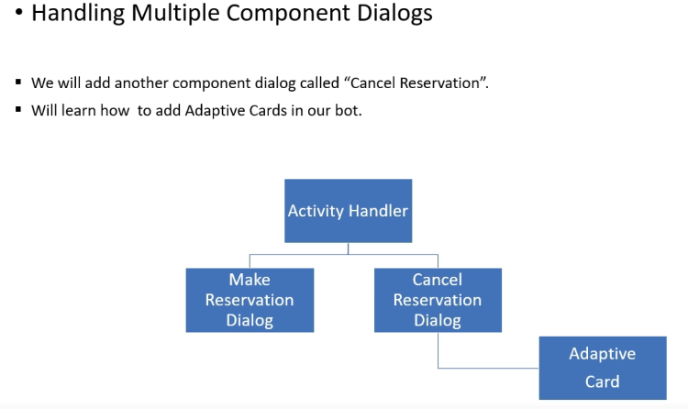

To Design an Adpative Cards – Go to <https://adaptivecards.io/explorer/>

We have handled multiple component Dailog(topics) via **Switch case**

Important to note that if the topic/dialog is complete , we have **reset** **previousIntent to ‘null’**  because otherwise it will the intent same and user will never be able to move from One topic to other(because the way if-else are written) i.e. It will always keep starting MakeResevration only even when MakeResrvation is complete. See line below:

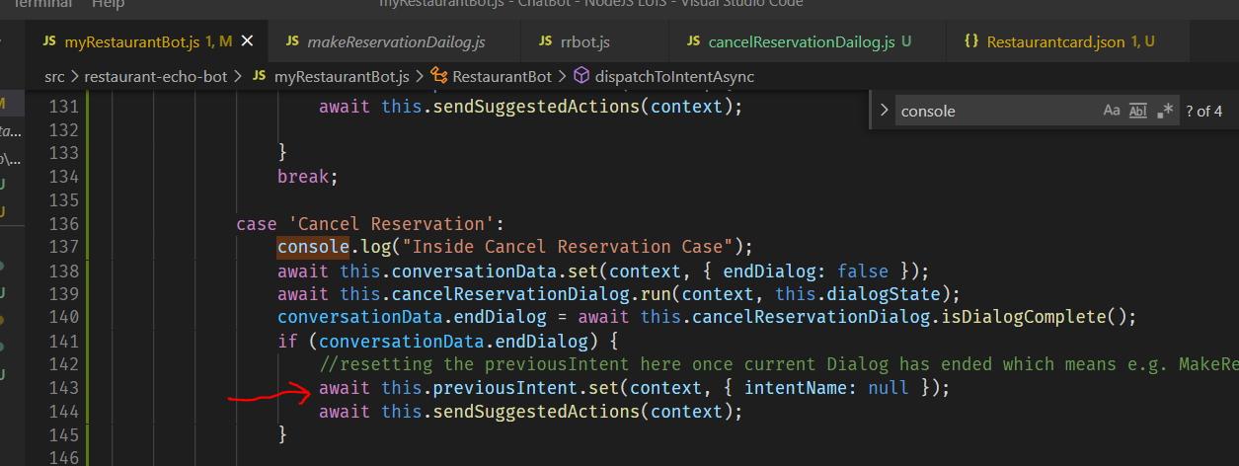

* **What if the user select ‘No’ at any step**

This can be handled by putting following line in each step:

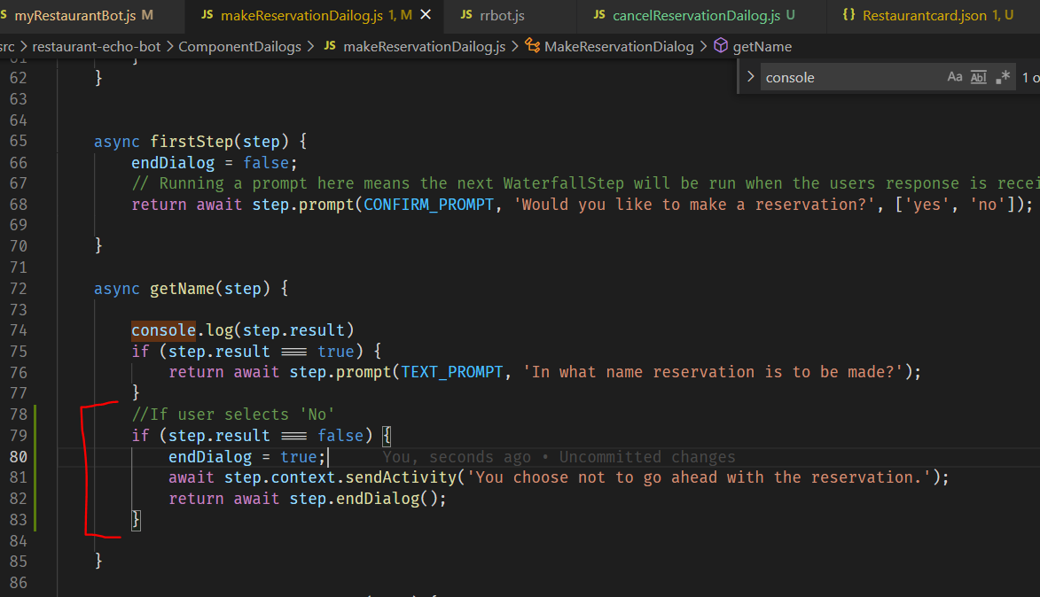

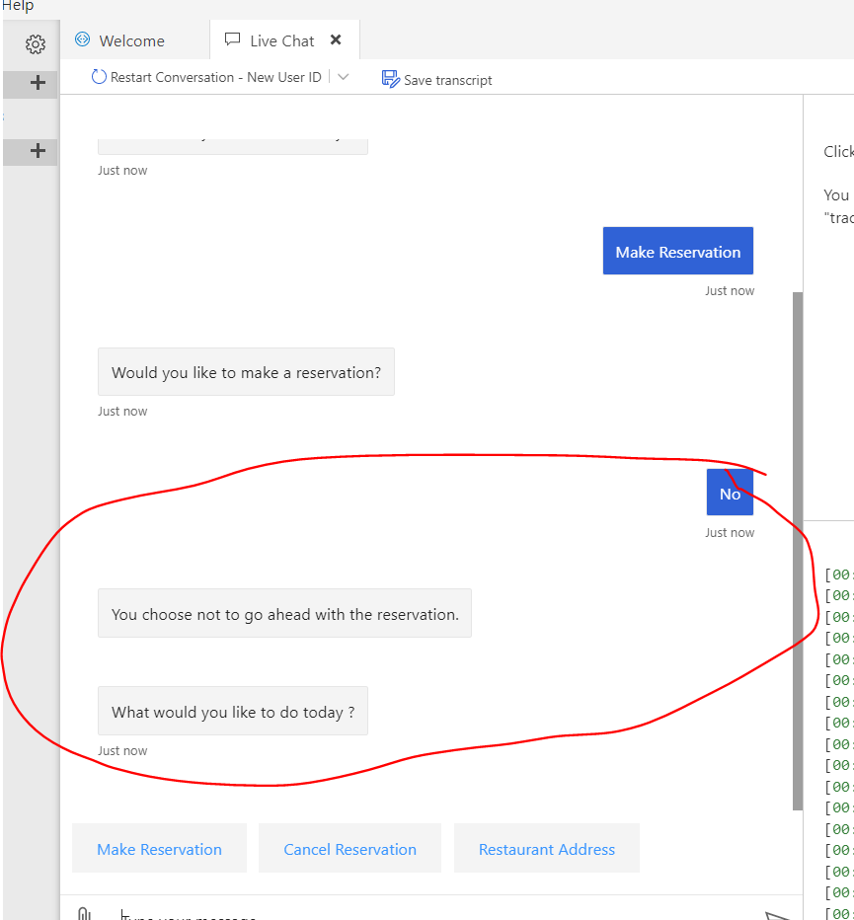

**LUIS Intent and Entities**

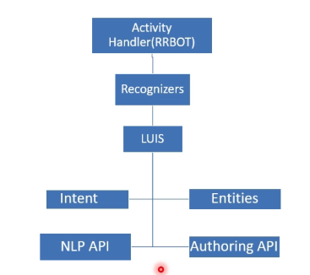

**Use of LUIS**

We will create **LUIS recognizer**  and use to make calls to NLP API which is going to provide us the **intent** or one of the topics and also it will provide us a **prediction score**  that we can use to route our incoming activities to one of our underlying component

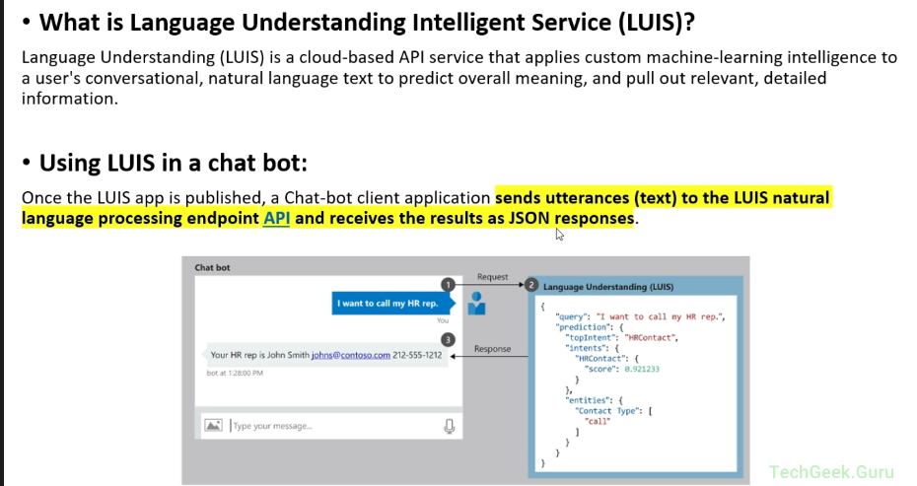

You can send text/utterances to LUIS from your chatbot client appicaiton and the NLP endpoint API will receive these utterances and give the result as JSON repsonse and also we are going to get the score (see JSON format in the right side) for that particualr intent which shows the confidence level of the LUIS app.

If you have any **entities** built into LUIS , it is going send back entities.

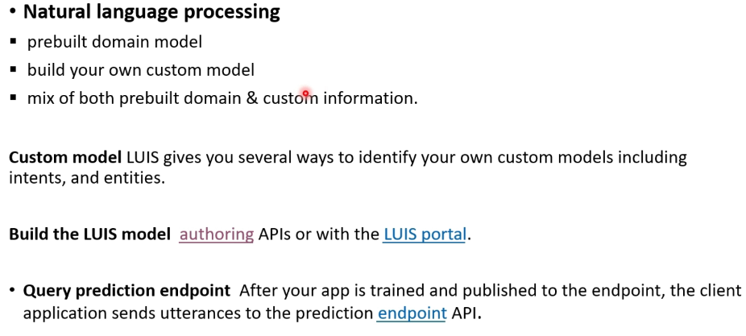

You can either create your own model or use prebuilt ones via **authoring API**s or LUIS portal.

* **Steps:**

1. In LUIS (<https://www.luis.ai/> ), we first create an app.

**Earlier we hardcoded the topics (make reservation or cancel reservation) and use the Switch case to route the incoming user activities.**

**But now we will route the incoming activity(make reservation or cancel reservation) to LUIS NLP API to fetch that topic instead of just matching the text in switch case.**

**Creating Intent**

1. We will create an Intent . Below is an example of **makeReservation** intent created on LUIS portal:

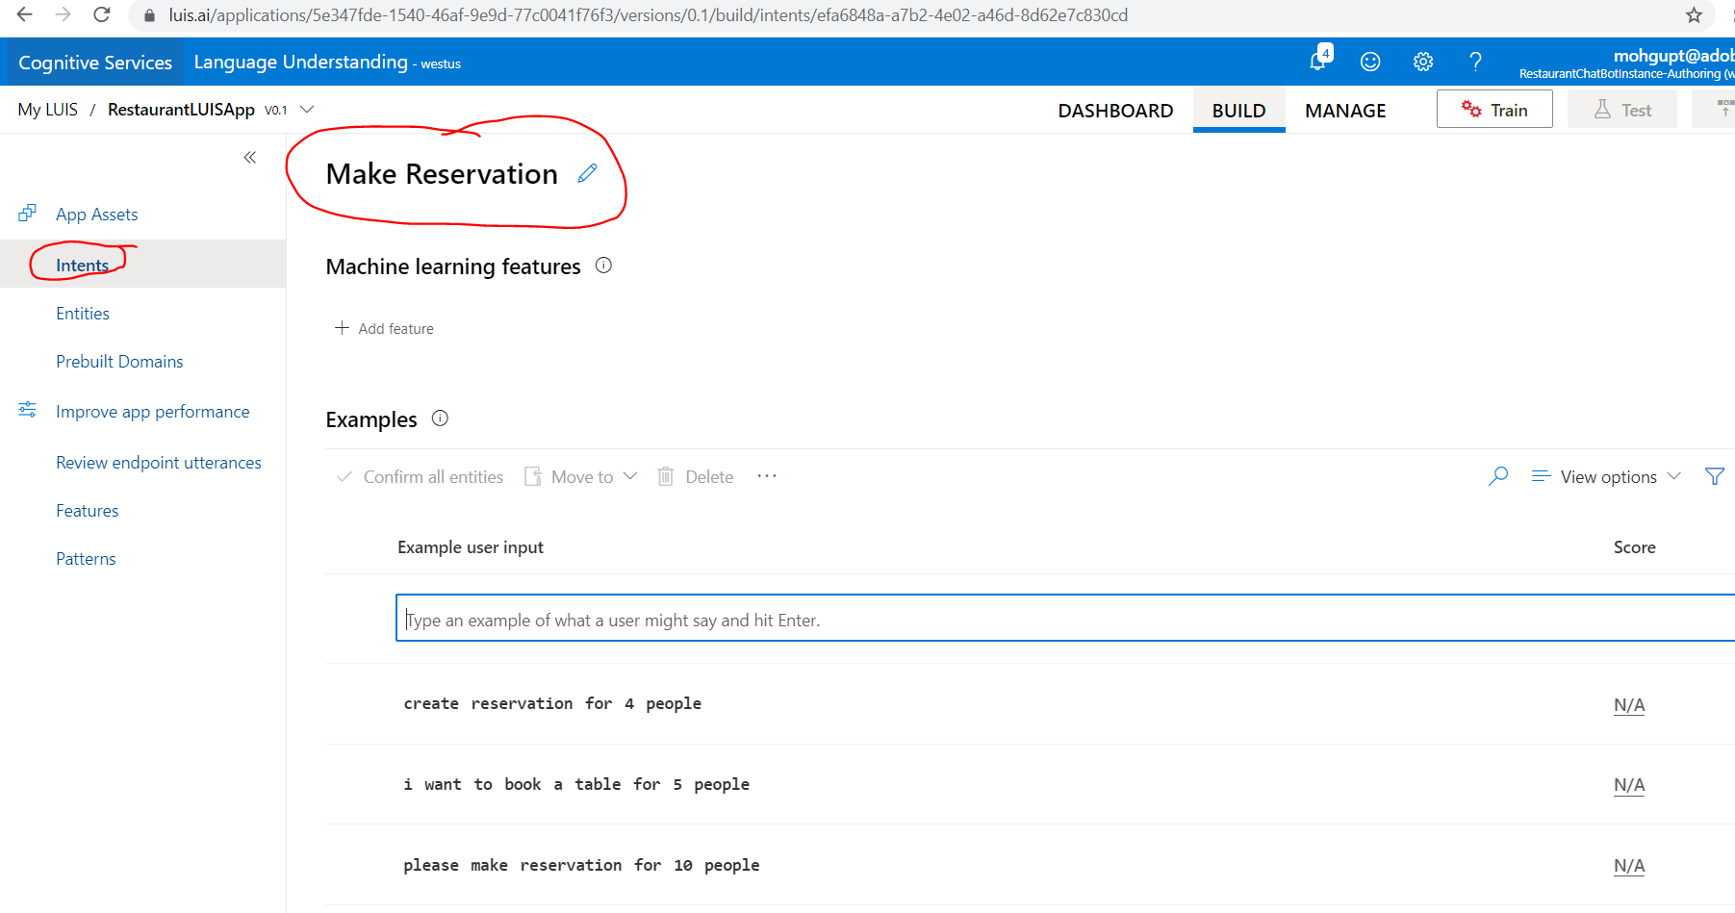

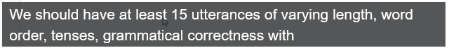

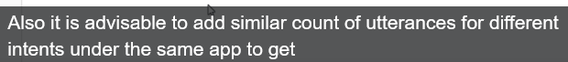

Similarly for Cancel Resevration below:

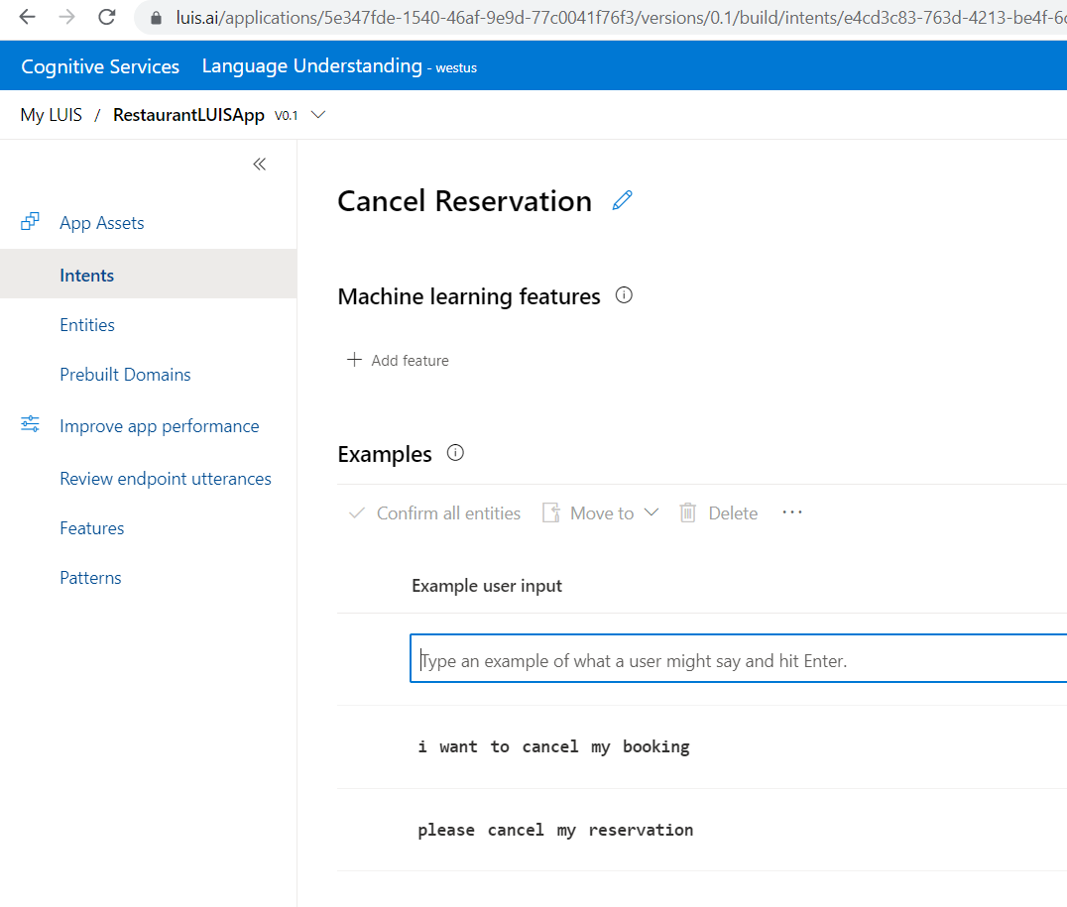

**Final Intents**

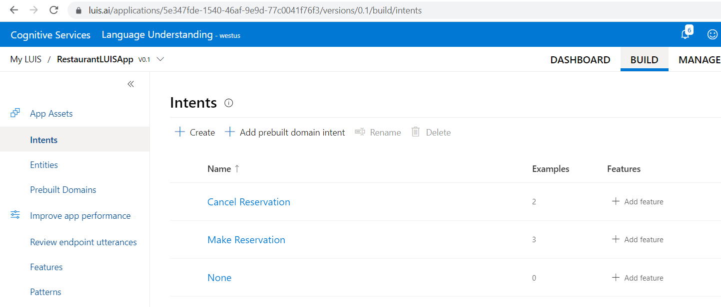

Notice we have ‘**None’** intent as well- which is taken when none of the topics are matched. Here you can either ask the user to end the conversation or give more directions to continue the conversation.

By Default if nothing matches and you have trianed your None intent then LUIS will incorrectly gives incorrectly give back one of the intent ie. Make Reservation or CancelResrvation in this case.

1. **Creating Entities**

**Entities defines** a data which needs to be extracted from within the utterances. So when a user types a message that message can contain some unstructured data that we need to extract and use it as entities or use it somehwre in our waterfall models or dialogues to do some business logic.

Example below:

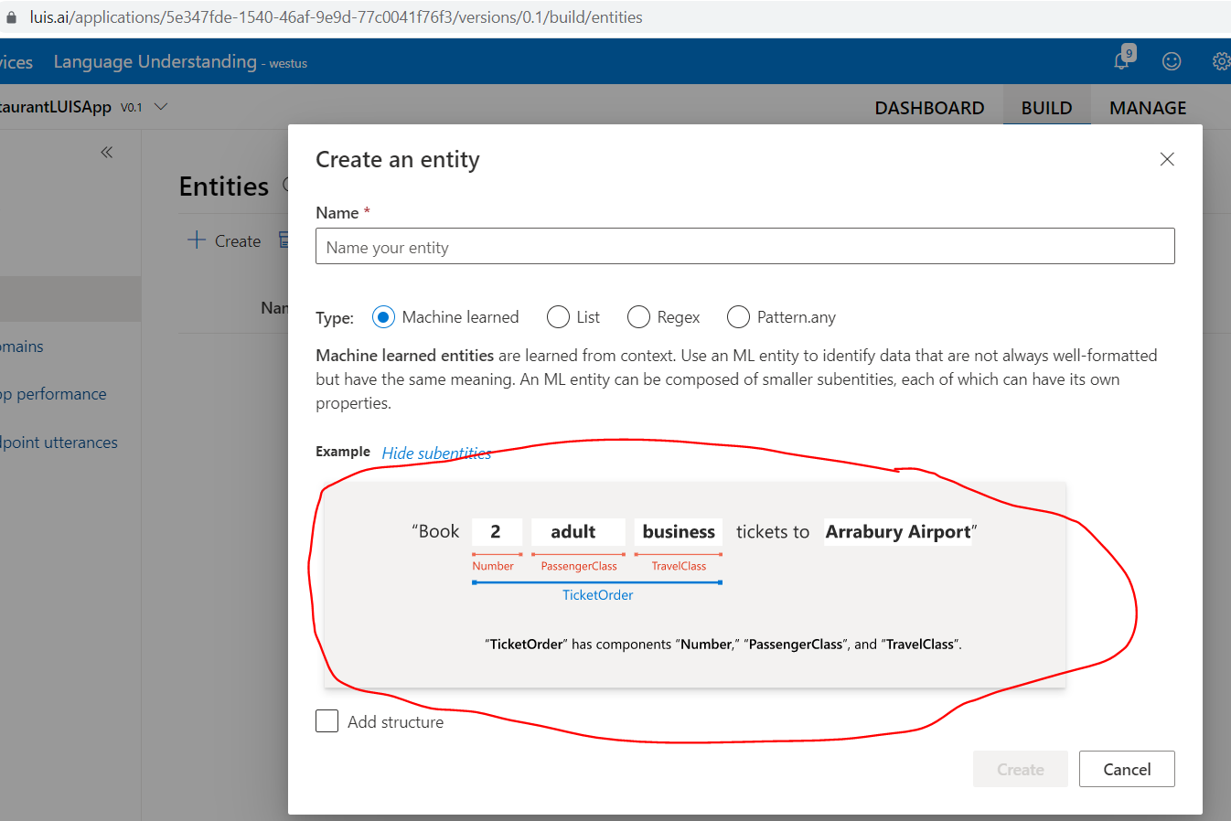

We are going to create entity for NoOfParticpants

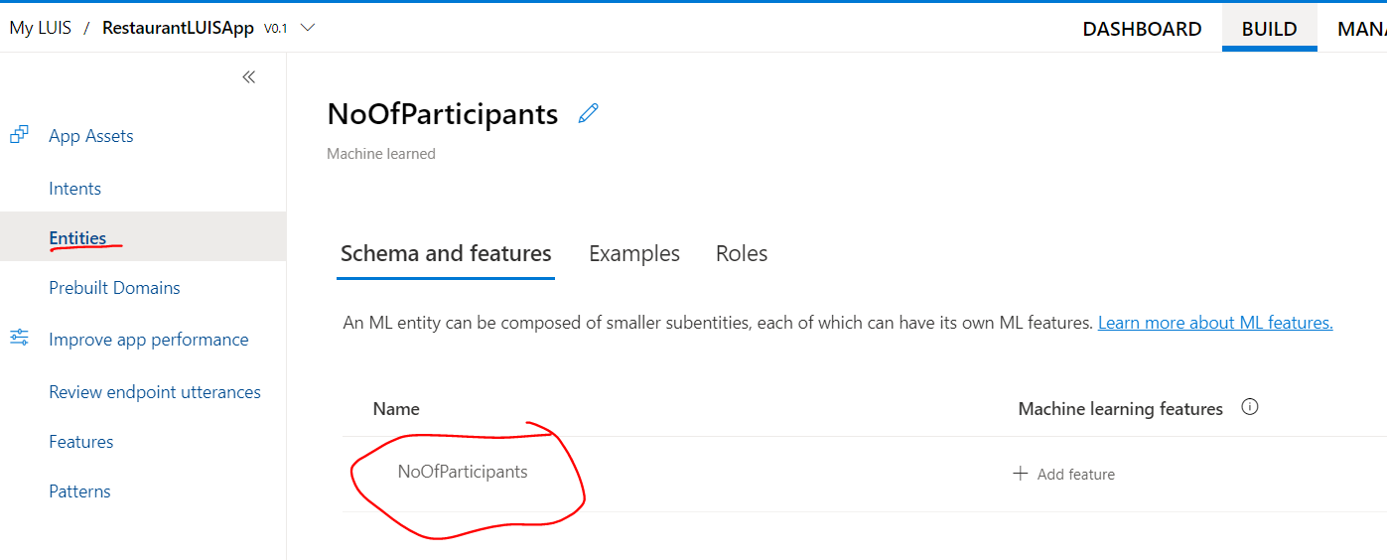

Now we will use this entity in Intents

Now in the Intent message we have hardcoded the noOfparcipants that the user expects to receive from Bot like shon below:

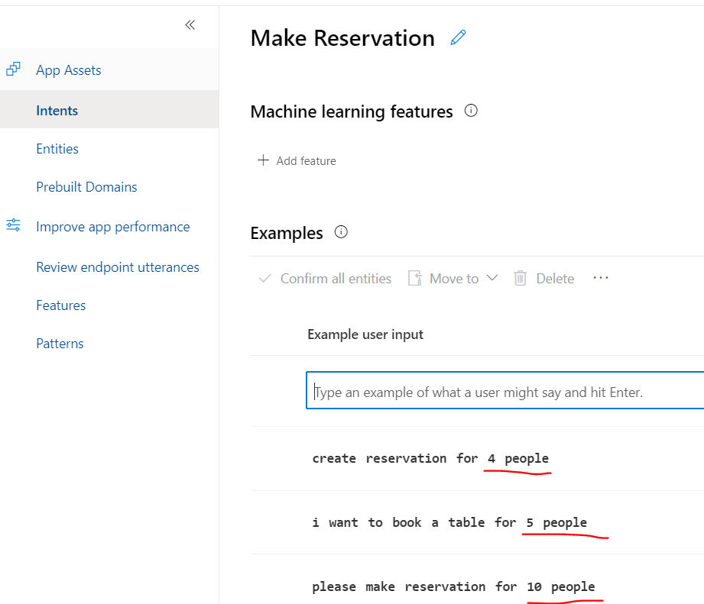

If you want to extract this hardcoded message and you do not expect bot to get the same information from the user, we can simply train our intents to fetch this data by turning them into entities.

We will change the numbers to entities like below:

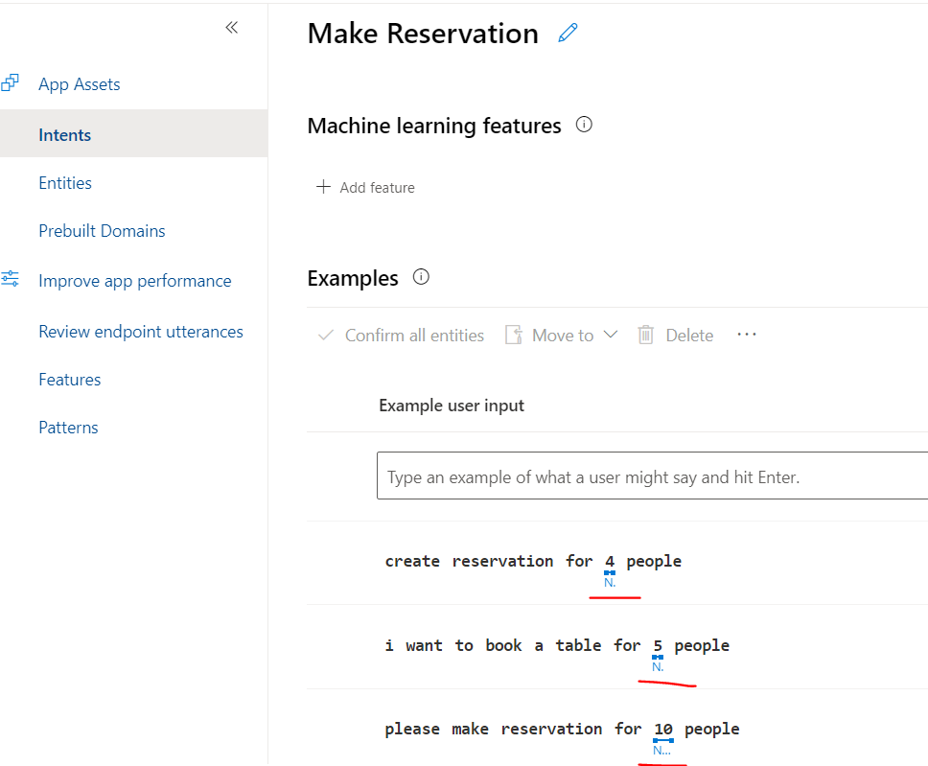

1. **Creating Phrase list**

Now, there might be a case when user really does not type number 4 in number format , the user might type another number.here you can use **Phrase list**  where you can define kind of different synonyms that you can use.

**To create Phrase list**, go To **LUIS app**- > **Features**  as shown below:

You can give possible values as shoen below:

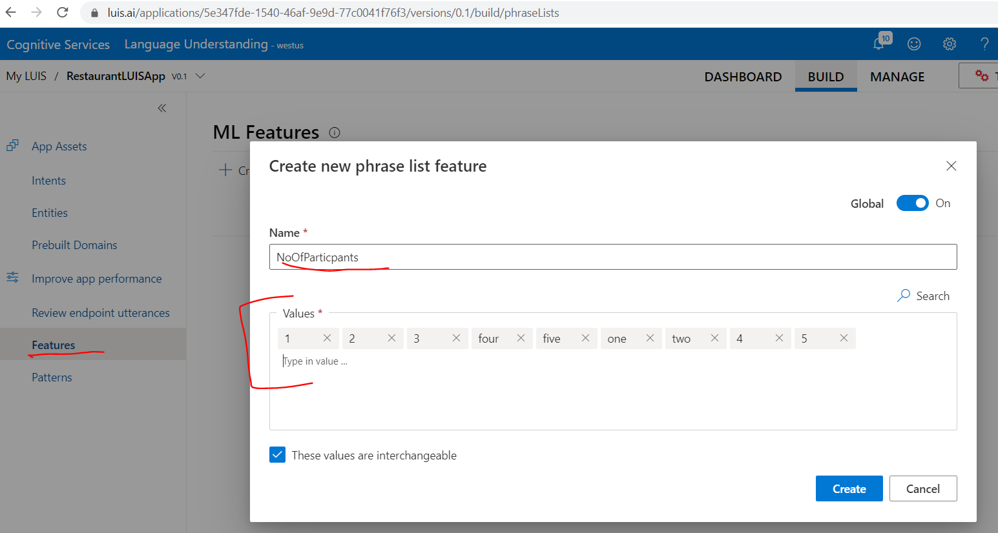

1. Aftre **Intent, Entities and PhrseList** are created, press on ‘**Train’** which wil trian our application.

And then you **‘Test’.** See below. **Always Train and ‘Publish’ the model after making any change in LUIS app(front end)**

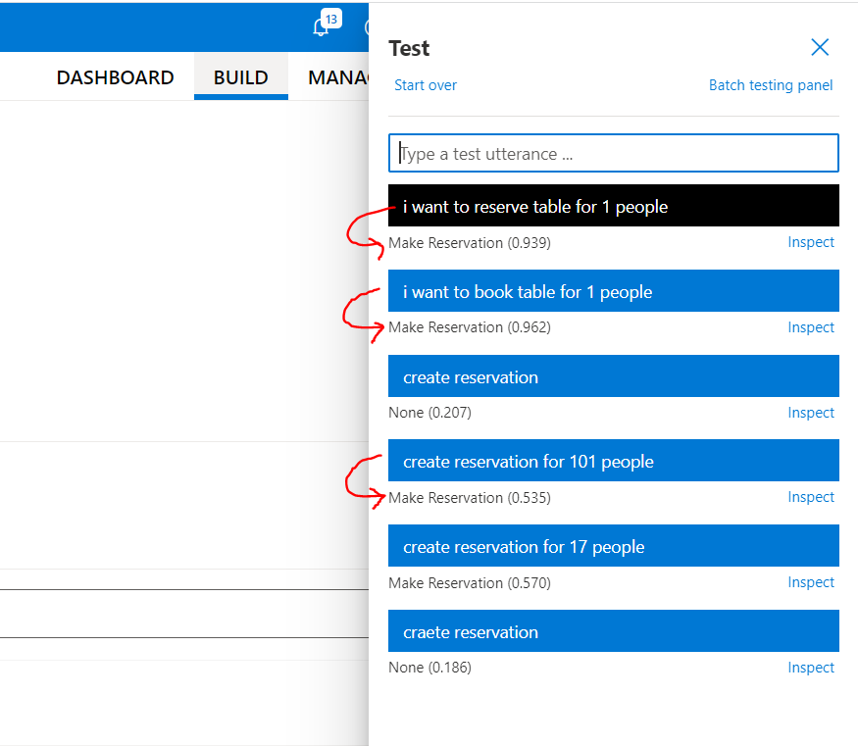

We can notice it is returning the current Intent name(make Reservation) based on sentence passed as input

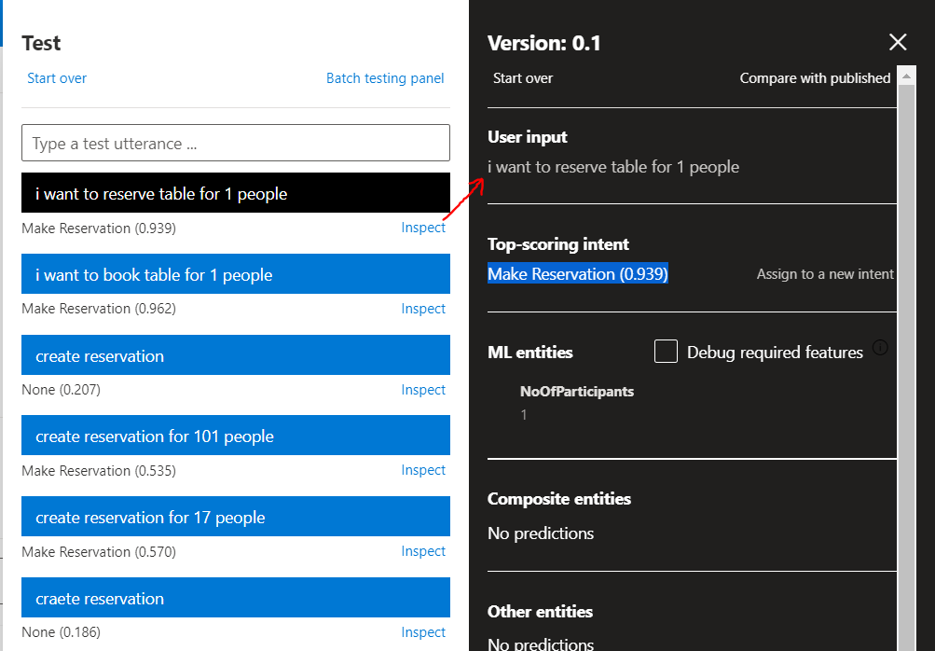

You can check the Score by clikcing on ‘Inspect’ as shown above

1. Next we can **publish** our app by clkicng on publish as shown below. Om publish it will give us an endpoint URL::

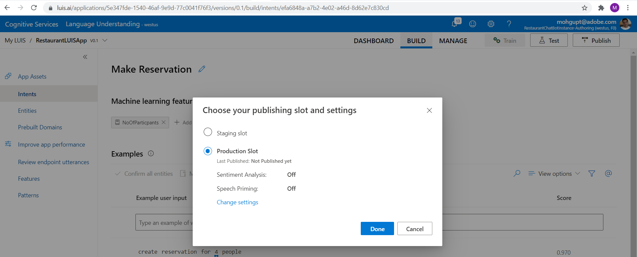

**LUIS EndPoint URL received.**

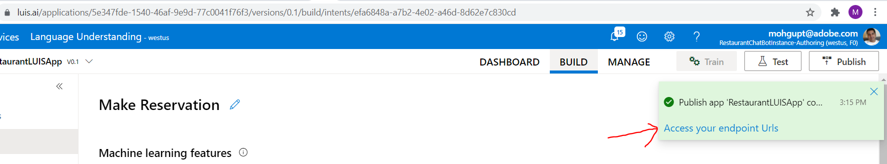

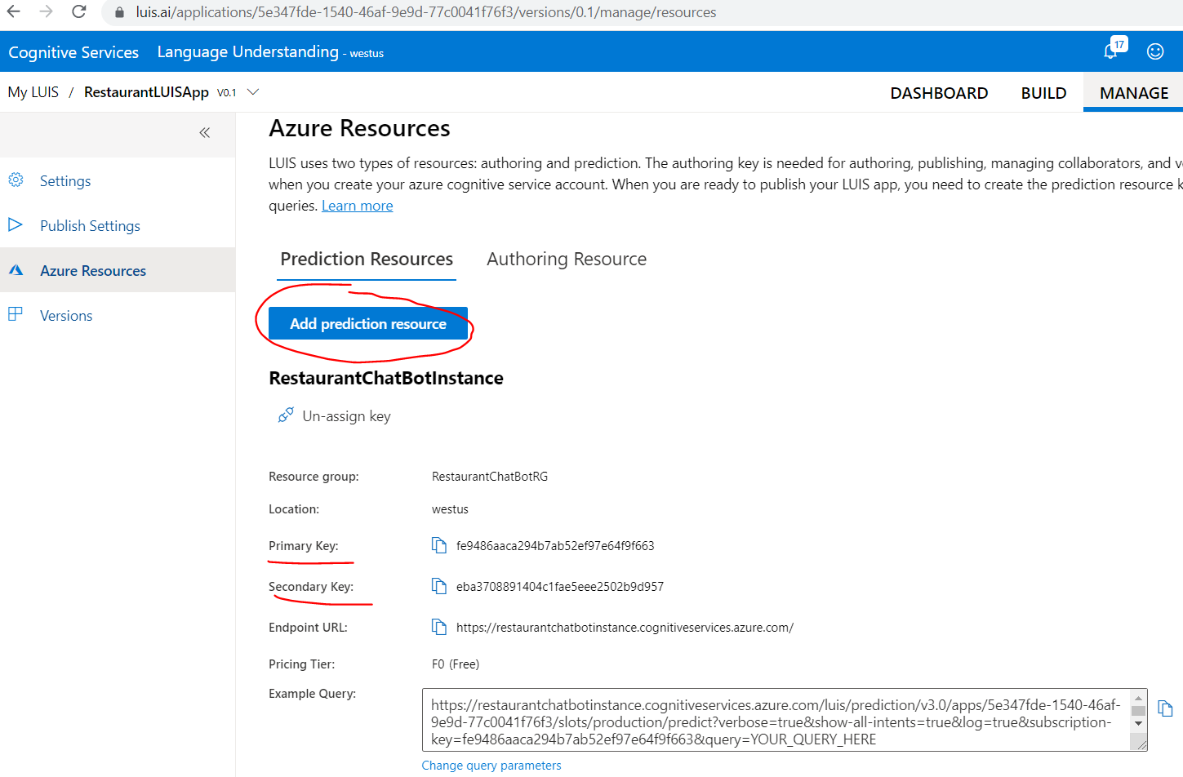

I tiwll give you the key of LUIS app created to use it.

This key has some limitations , so we wil create another prediction resourse in our Restaurantbot.

There are 2 keys (Primary and Secondary) provided by azure and this is going to make rotation of keys easy for you. If Primary key is expiring than you can use Secodnary key.

**Using LUIS in Node App**

In order to connect to LUIS NLP prediction API, we need to import **LUIS recognizer** via **botbuilder-ai** module as shown below:

const { LuisRecognizer, QnAMaker } = require('botbuilder-ai');

npm install botbuilder-ai

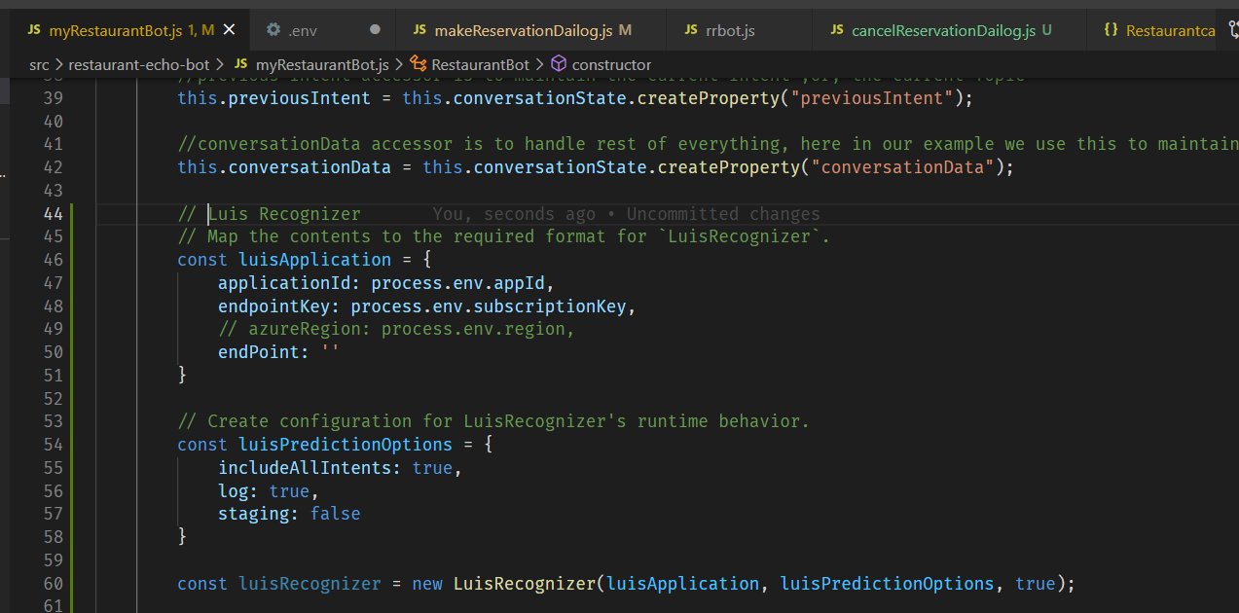

Here we need to give appId, subscriptionKey, etc via enviorment varibale, so we defined them in our .env file.

AppKey and SubscriptionKey(it is primary key only) can be found here as below:

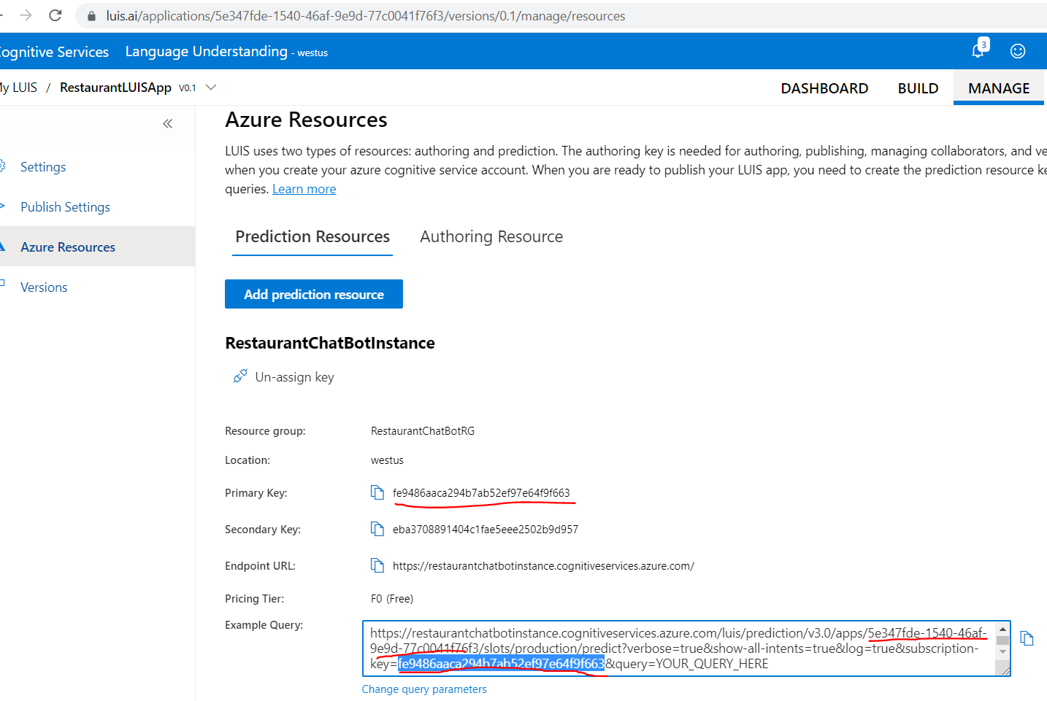

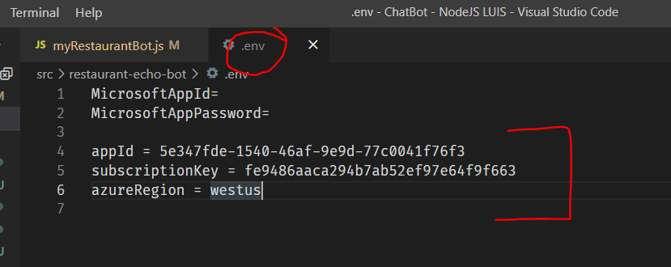

Not we will inboke LUIS NLP API in OnMessage as shoen below:

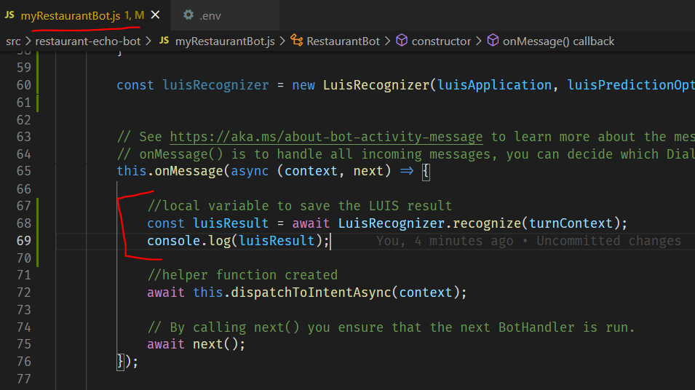

Now you can try sending the message from the bot. You can see what all messages have been sent by the user via bot to LUIS API from “Review utternaces” section as below: You can map the incoming messages with the configured intents from the dropdown like below:

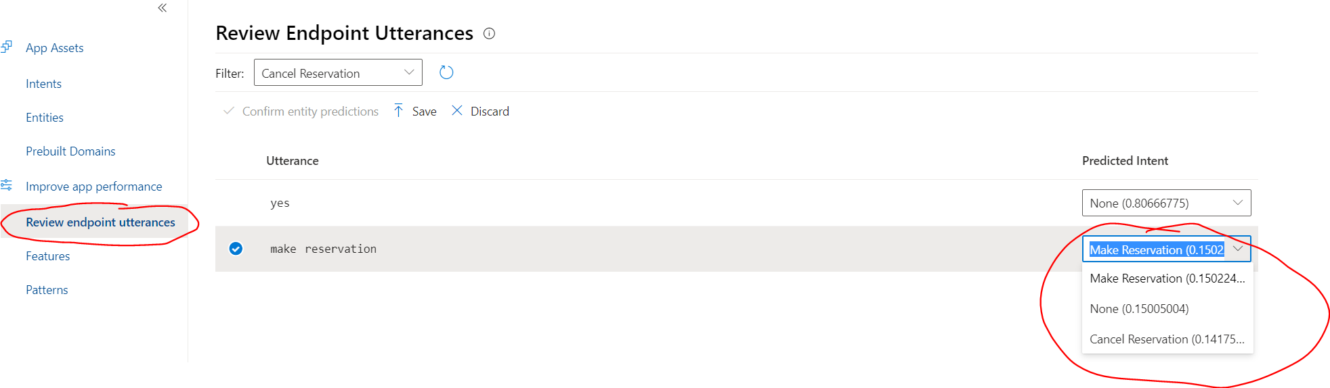

**Remember you to train the model againby using ‘Train’ and ‘Publish’ button**

You can check the topScoring Intent from the result rturned from the LUIS API call as shown below:

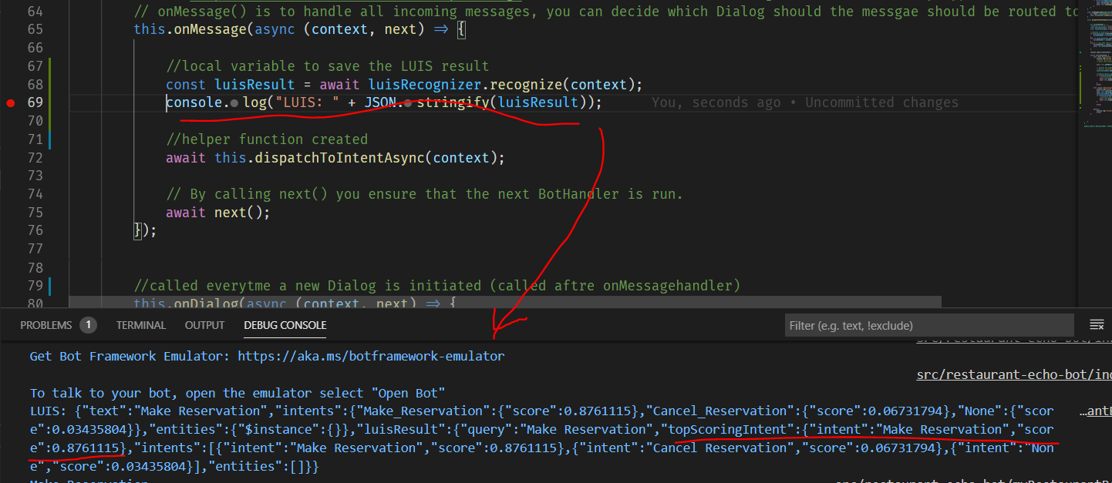

Next, we get the top intent using topIntent() method and pass the intent to the dispatchToIntent() function

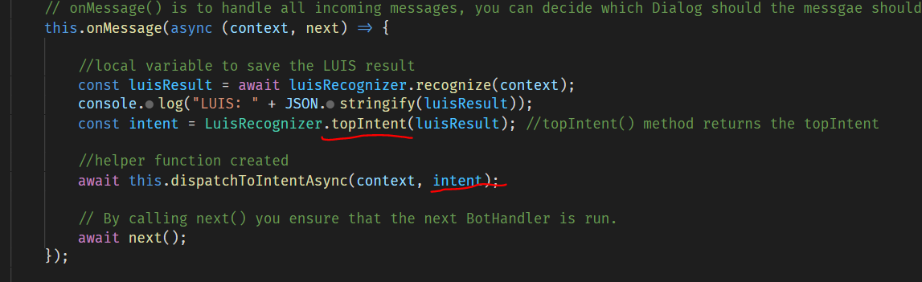

Next we replace the the hardcded intent value(context.activity.text) with LUIS generated intents as shown below:

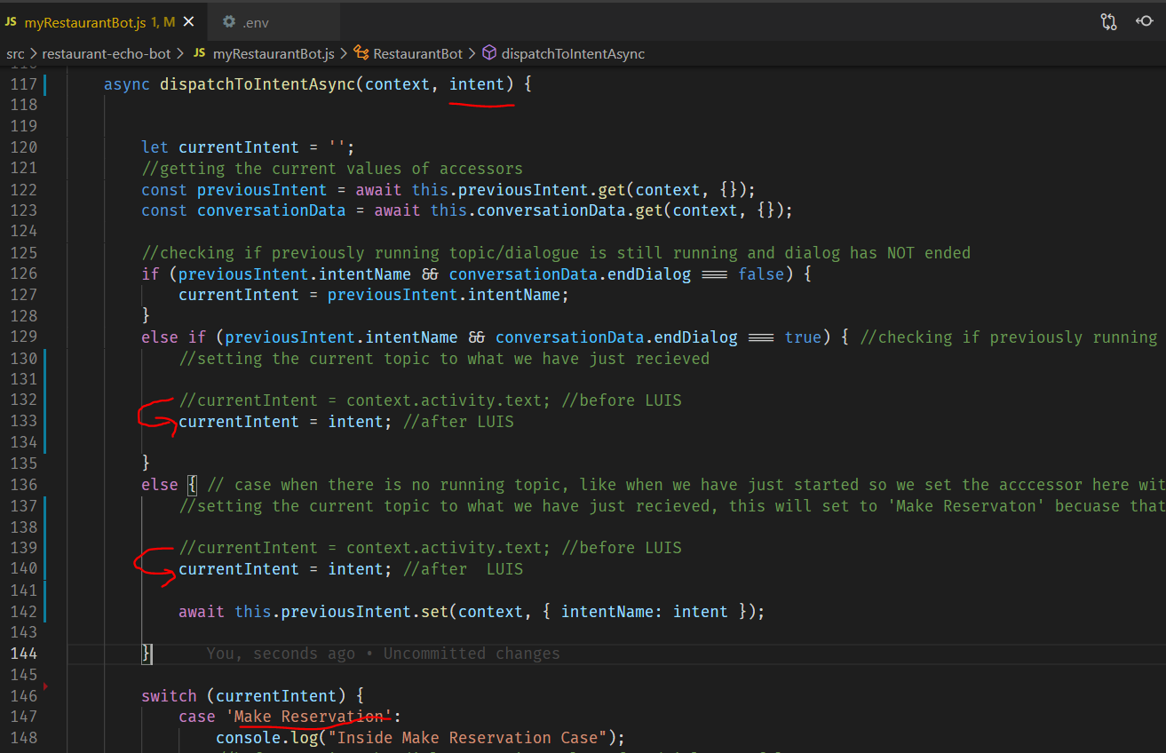

**Important thing to remember, our intents should not have any space, if we added intent in LUIS with space, it will be replaced with underscore(_)**

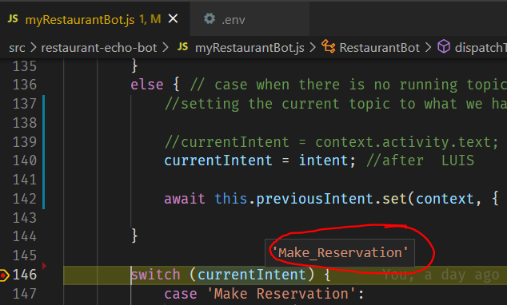

So since our intent in <https://luis.ai> has intent with space , we made the switch case with underscore as shown below:

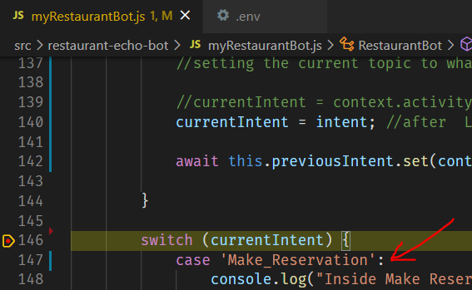

That is it.

* **Using LUIS Entities-** We will use entities to make ou bot a little smarter.

Entities too, e.g noOfParticpants requested by user for reservation in his intiial message which we will configure in LUIS app as entity (kind of placeholder) and pass it to the dialog and with this we can avoid asking the number of particpant as a sperate prmpt.

Working below:

We will fetch the entities from thr luisResult object only like we fetched intent.

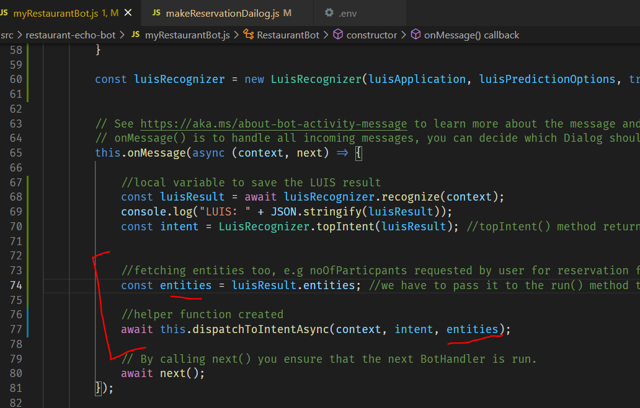

Passing entities in run()

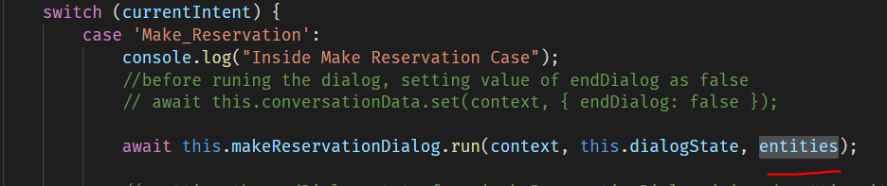

We can pass any value to first step of waterfall dialog by passing itas a paramter in beginDialog() method and fetch it in first step as shown below. Later you can assing it ‘step.values’ to access in rest of the subsequent steps. See below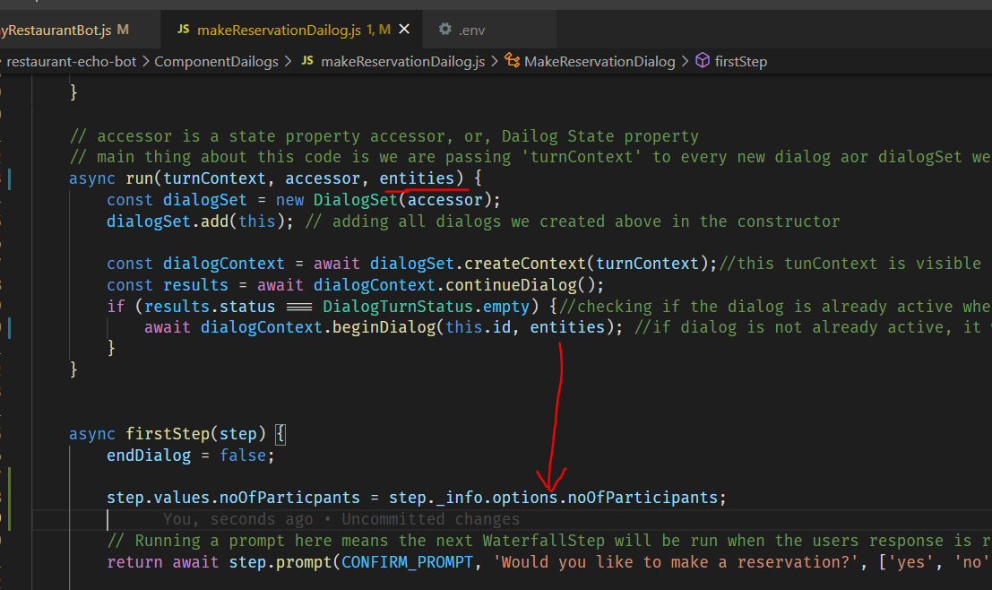

Avoiding noOfParticipants prompt if value comes in entities. See below

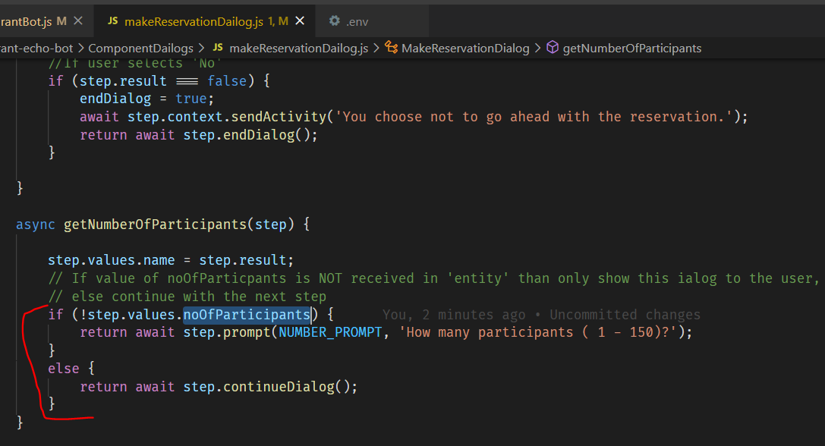

* **Working with QnA Maker**

**Idea of QnAMaker**

When we have a null intent from LUIS, we want the query to be routed to QnAMaker but only when previous intent is also null , which emans when there is no dialog that is running or initiated right now, we can serve the query via QnAMaker and end the conversation with suggested action. So this will not abruptly end the conversaiton between user and bot.

Just like LUIS we are going to add QnAMaker recognizer in our activity hanlder which is our RestaurantBot or mainDialog. Then using the recognizer we are going to make HTTP post calls to our knowledge base API which we will get upon publishing our KB from the [**https://QnAMaker.ai**](https://QnAMaker.ai) platform.

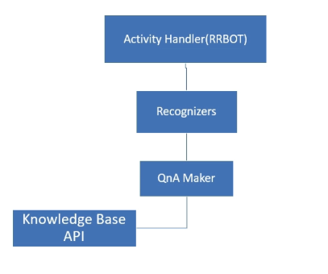

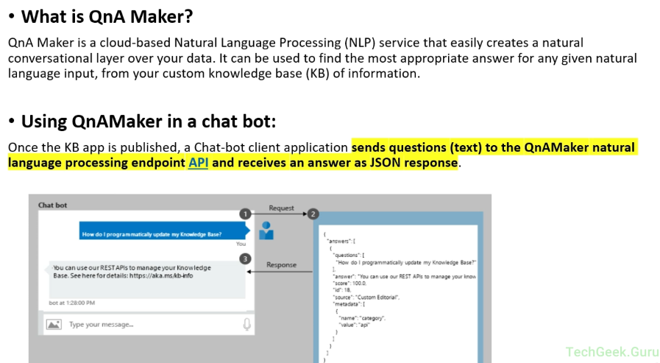

With QnMaker, we are again going to create a Knowledge base and add Q and A pairs and it is similar to LUIS only where added intents. We will train and publish it in the same way.

**Q and A Maker is mostly used to send some Static information like FAQs or some information in QnA format or in PDF format. We can use these PDFs or URLs to train our knowldegBase. See example in above screenshot.**

**QnMaker can also be used for chit-chat. These are the quesitons that are totally unrelated to the domain for which bot is created because sometimes we want to make our Bot little friendly. Like hows the weather, how are you etc.**

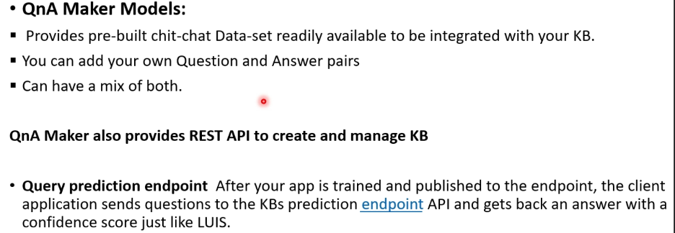

**Sample Queston and Answer in QnA Maker**

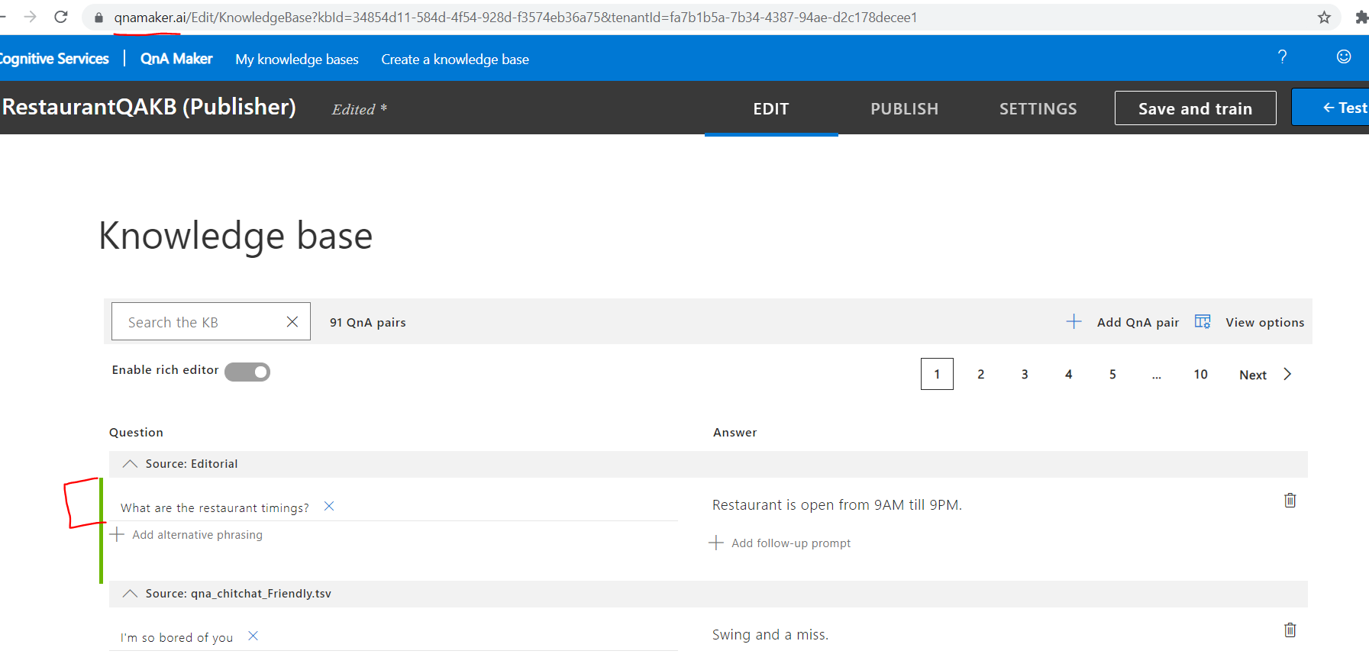

Once published, QnAmaker will give a **KnowledgeBaseId, HostName** and **Endpoint key** like below:

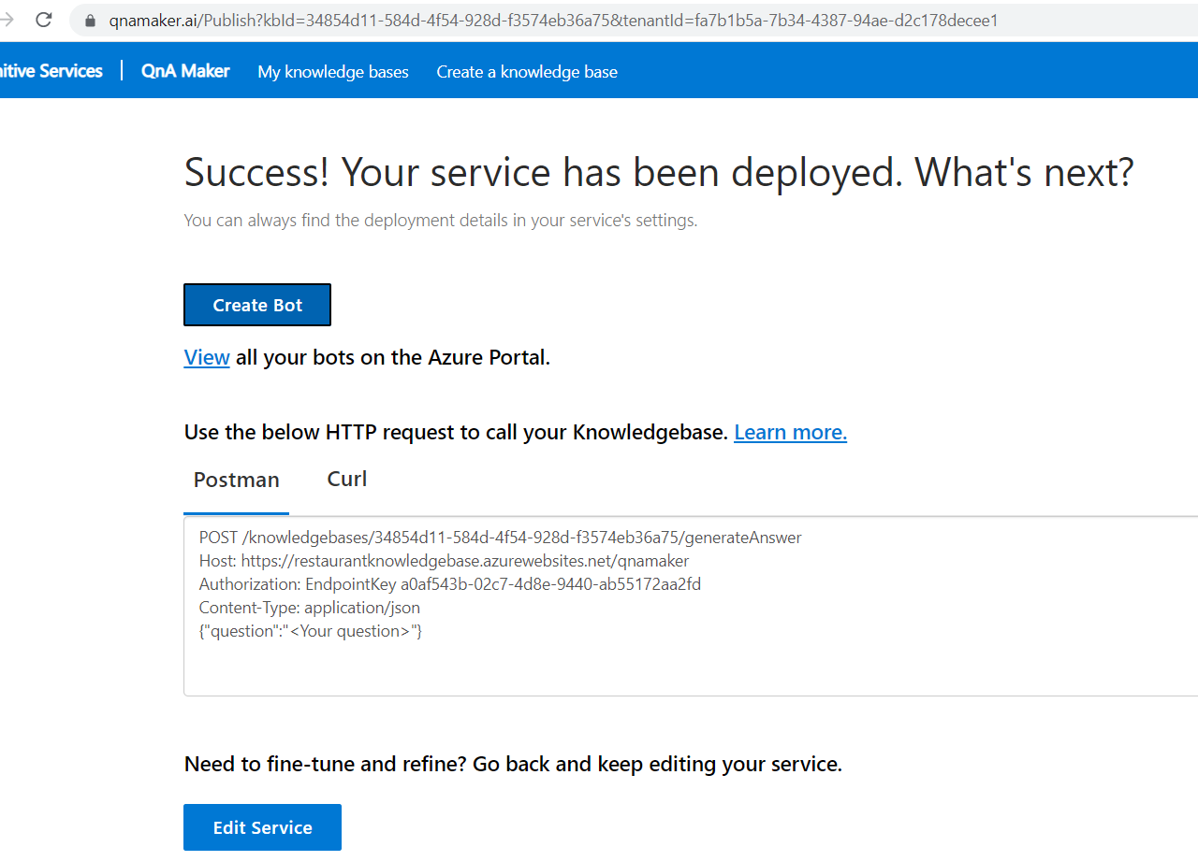

Setting the configurairon in Bot constructor:

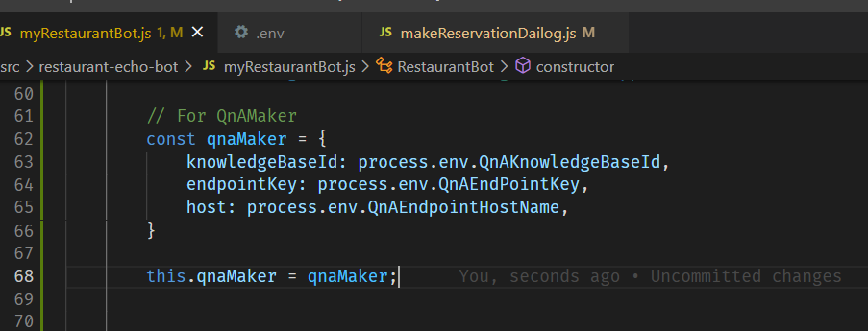

Setting the values in .env file

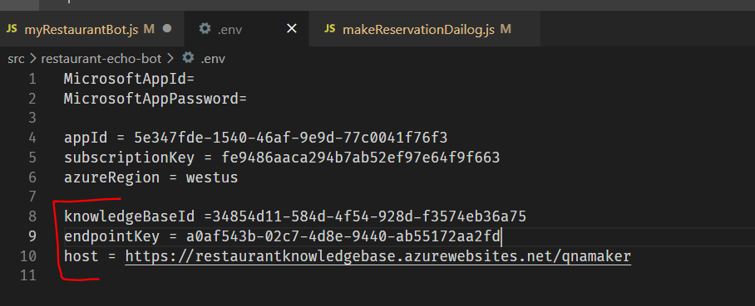

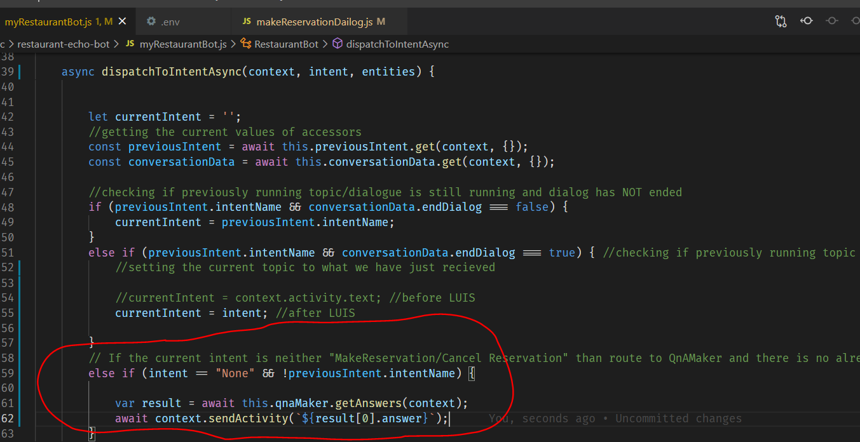

**This way you can have multiple Dialogs and have different ‘intents’ mapped to them and have multiple Ques Answers to have a comprhensive bot.**

* **Deployment(hosting) to Azure**
* Check this link for details: <https://docs.microsoft.com/en-us/azure/bot-service/bot-builder-deploy-az-cli?view=azure-bot-service-4.0&tabs=csharp> 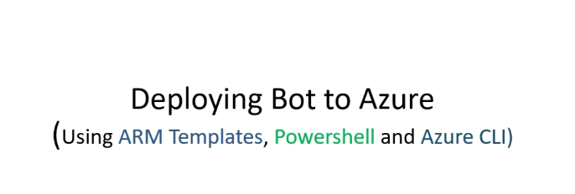

1. Download Azure CLI for Windows

<https://docs.microsoft.com/en-us/cli/azure/install-azure-cli-windows?tabs=azure-cli>

1. Login to azure from powershell window with following command

**az login**

This will open browser window and ask for login. On successful login, power shell will show below detials:

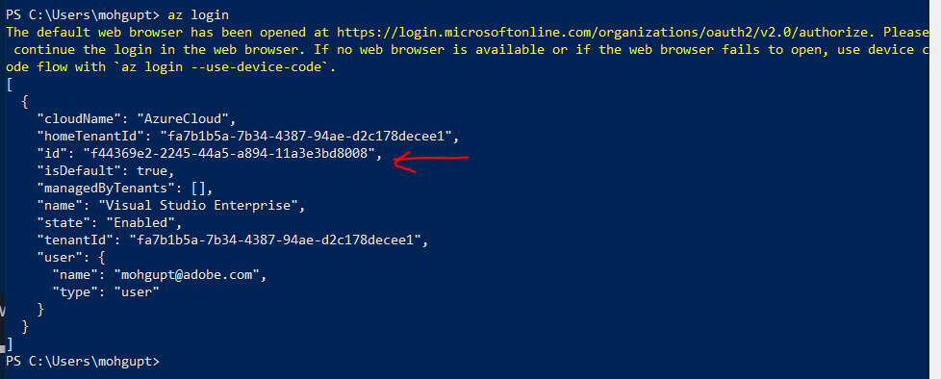

id shown up is **Subscription id**

1. Run the following command to set the subscription-

**az account set --subscription "f44369e2-2245-44a5-a894-11a3e3bd8008"**

1. When you deploy any app on azure like bot or any azur hosted service, you need to create Azure Active Directory Application ID first. This application ID , in case of a hosted bot is required for users to be able to interact with the bot via set of channels such as webchat and it also provides a definition of oauth connection settings to authenticate auser ans create a token used by the bot to access protected resources on behalf of the user..
2. We want our Acitive directory App Id to be visible to other tenants because we are going to connect other channels like WbChat, skype, FB messanger.So we have to make out bot’s tenant id to be accessible by those channels. To do that, run the following command:

**az ad app create --available-to-other-tenants --display-name "rrwebappbot" --password "pass@1234"**

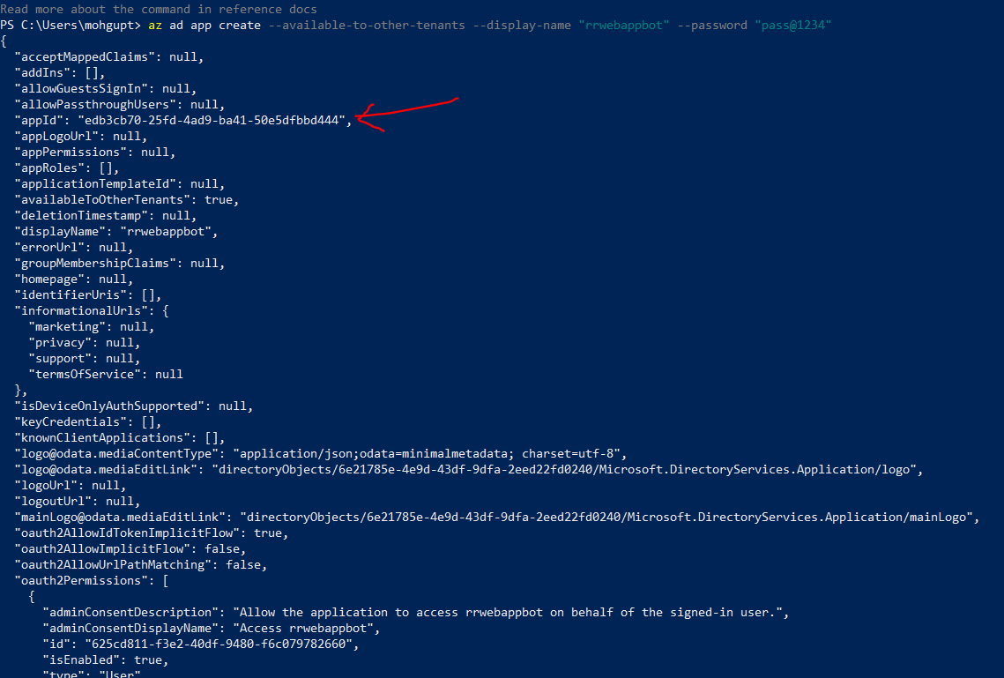

Highlighted above is the **App Id.** We are going to saveand **AppId** and the **password (password is the AppSecret too)**

"appId": "edb3cb70-25fd-4ad9-ba41-50e5dfbbd444",

password "pass@1234" **(use sixteencharcters with numbers and spl charcters)**

1. Nxt we want to use the **ARM Templates** that we generated when we gernerated out initial bot using yeoman generator. Now lets go the ARM template we had saved in our RestaurantBot NodeJS Solution folder.

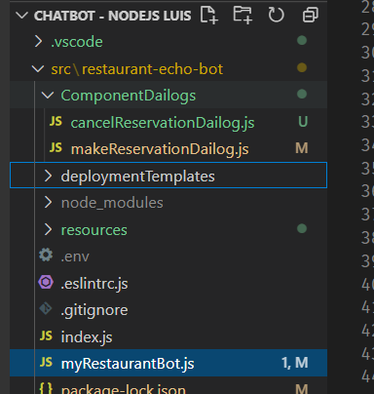

1. Now go to this folder from Powershell
2. We are going to use ‘new resources group parameters’ and ‘new resoure group template’ to create our web app service in azure

We have to provide all parmter values mentioned in templates, we need these values when we run the command to crate our web pp webservice.

1. Next we will run the following command:

az deployment sub create --template-file "<path-to-template-with-new-rg.json>" --location <region-location-name> --parameters appId="<app-id-from-previous-step>" appSecret="<password-from-previous-step>" botId="<id or bot-app-service-name>" botSku=F0 newAppServicePlanName="<new-service-plan-name>" newWebAppName="<bot-app-service-name>" groupName="<new-group-name>" groupLocation="<region-location-name>" newAppServicePlanLocation="<region-location-name>" --name "<bot-app-service-name>"

**Command with values filled in:**

**az deployment sub create --template-file "./template-with-new-rg.json" --location "westus" --parameters appId="edb3cb70-25fd-4ad9-ba41-50e5dfbbd444" appSecret="AtLeastSixteenCharacters_9" botId="restaurantChatBot_new" botSku=F0 newAppServicePlanName="restaurantChatBot" newWebAppName="restaurantChatBotWebApp" groupName="restaurantChatBotGP" groupLocation="westus" newAppServicePlanLocation="westus" --name "restaurantChatBotWebApp"**

Notice, we have given random names like “restaurantChatBot” as the value in all params in above comand. We can give any value

**Remember: WebAppName** highlighted above in the command will be used in deployment command

After the command you will see Web app created in **App services** section::

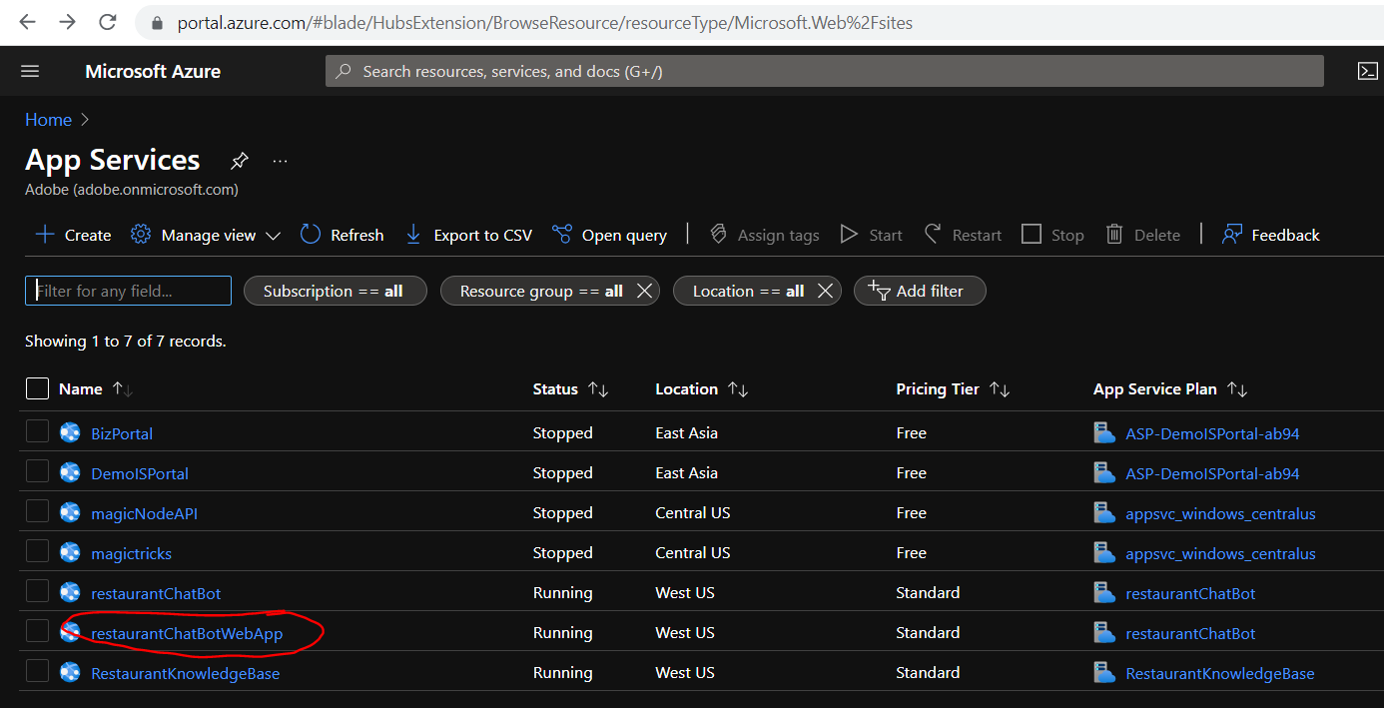

After this you can see the chatBotservice registered with Azure:

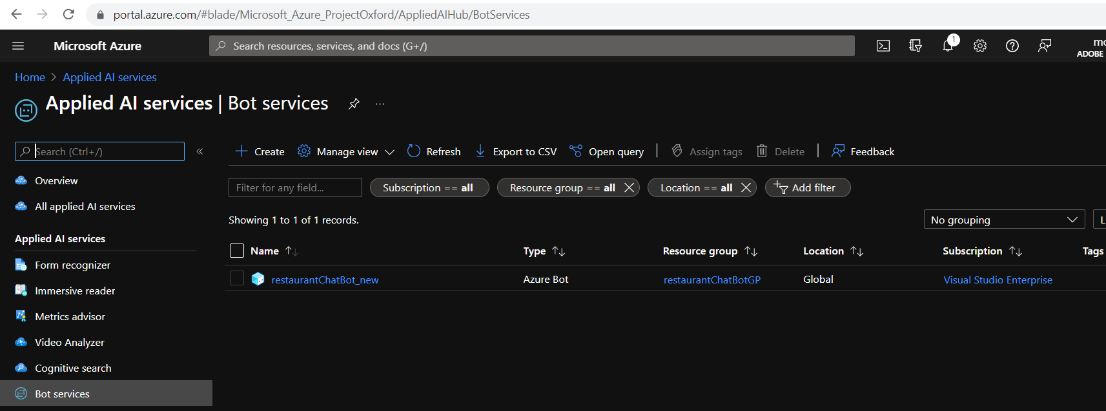

But if you go inside you wil see nothing has been deployed yet.

So far we have just set up the platform to run our bot but we still need to deploy our NODE Js code.

To deploy the Node JS code we have to create a web config file.

**Step 10.** Go back to Powershell, and **go to the root directly** of your NODE js Solution

Run the following command:

**az bot prepare-deploy --code-dir "." --lang Javascript**



This will create a web.config file

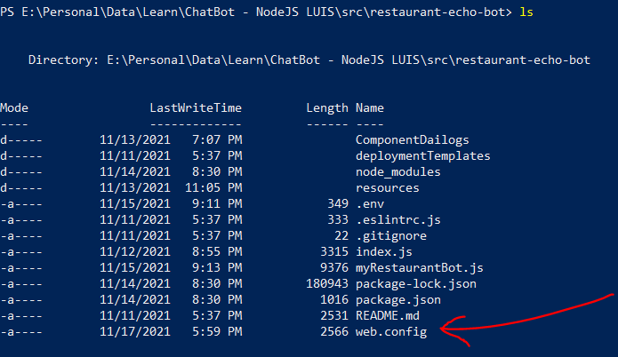

**Step 11:** Zip all the code files **with node_modules folder**

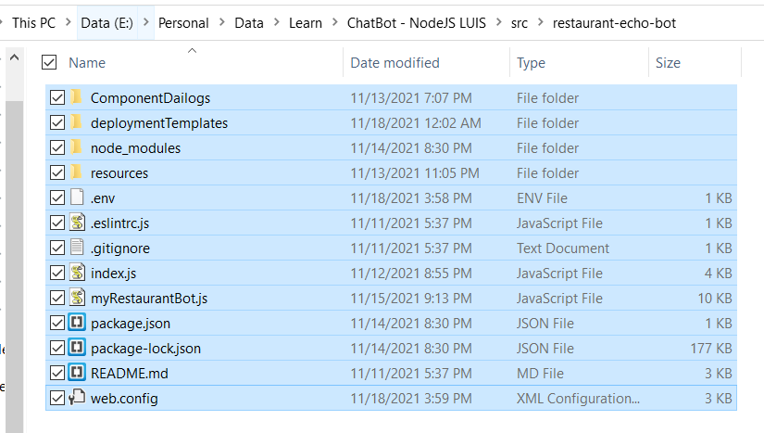

**Step12:**  Now we will deploy the code to our newly created Web App service

az webapp deployment source config-zip --resource-group “restaurantChatBotGP” --name "**restaurantChatBotWebApp**" --src “./restaurantchatbot.zip”

**name** used above is the WebAppName used in the previous command:

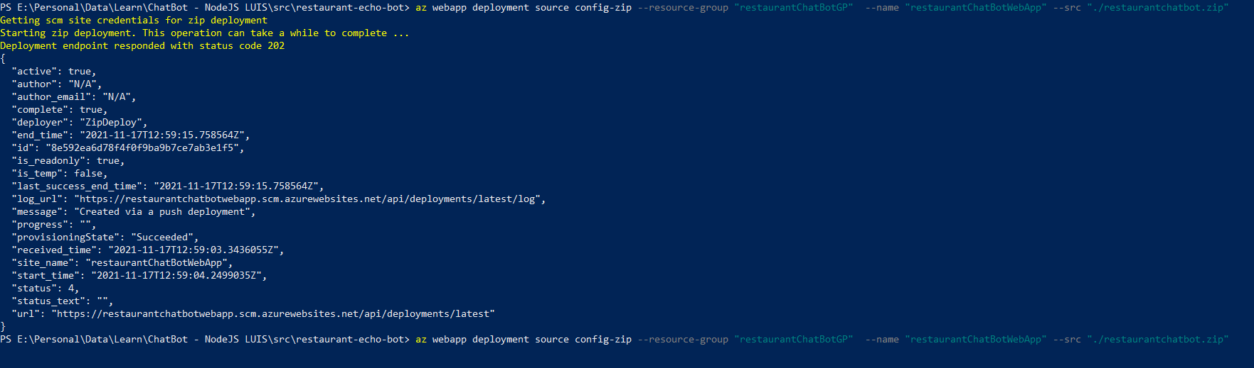

Now the code is deployed successfully and you can see all your code in “**restaurantChatBotWebApp**” App service in azure.

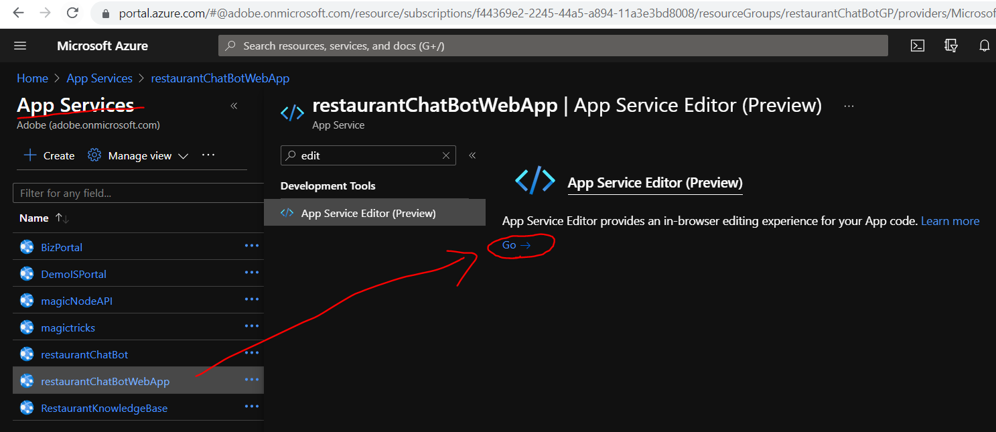

Press **’Go’ under App Service Editor** to see the code.

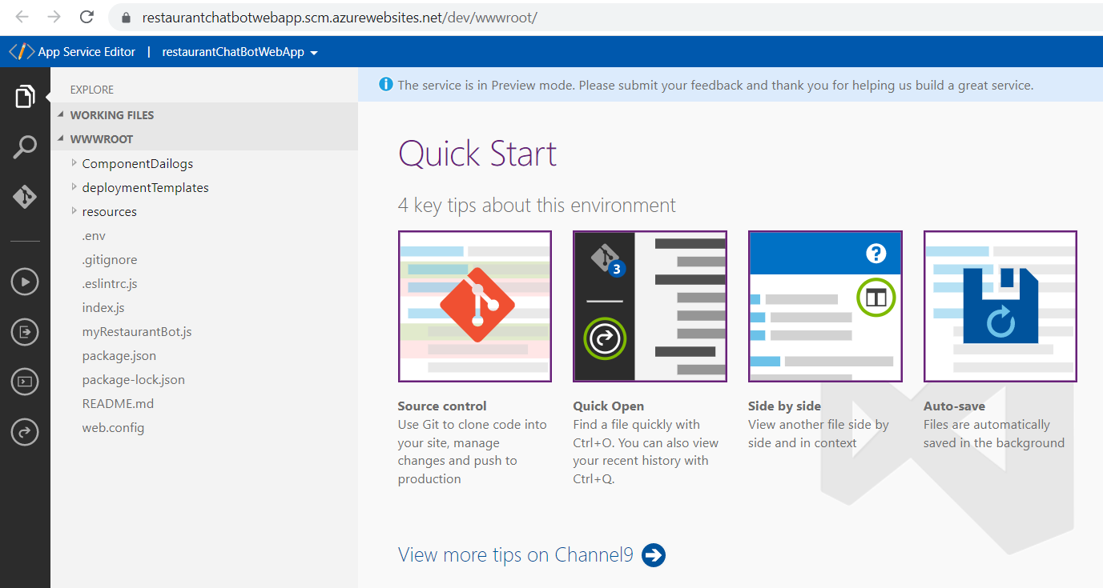

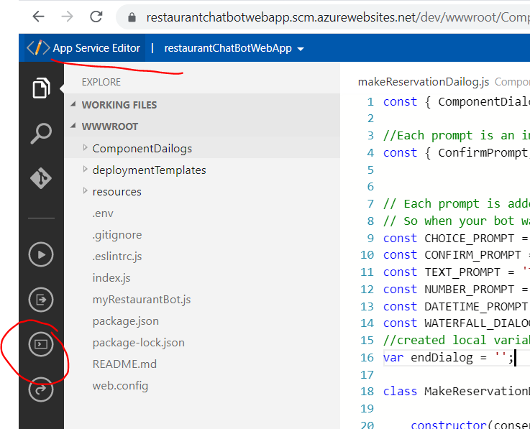

‘**console’** – window to run commands

* **Testing the Bot**
* **Opening Channels for Bot**

We can configure channels via which we want to interact with the bot. Go to Channels section in Bot:

Open Applied AI Services -> Then go to your Bot -> Channels (as shown below)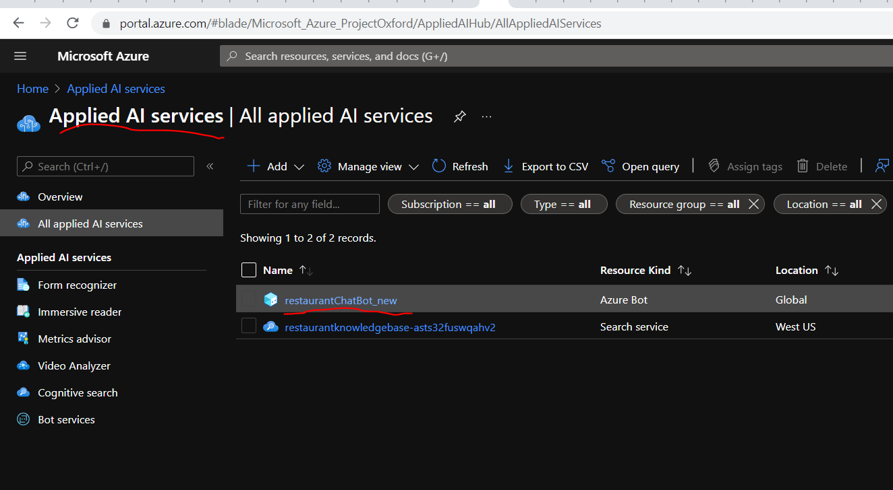 **--->**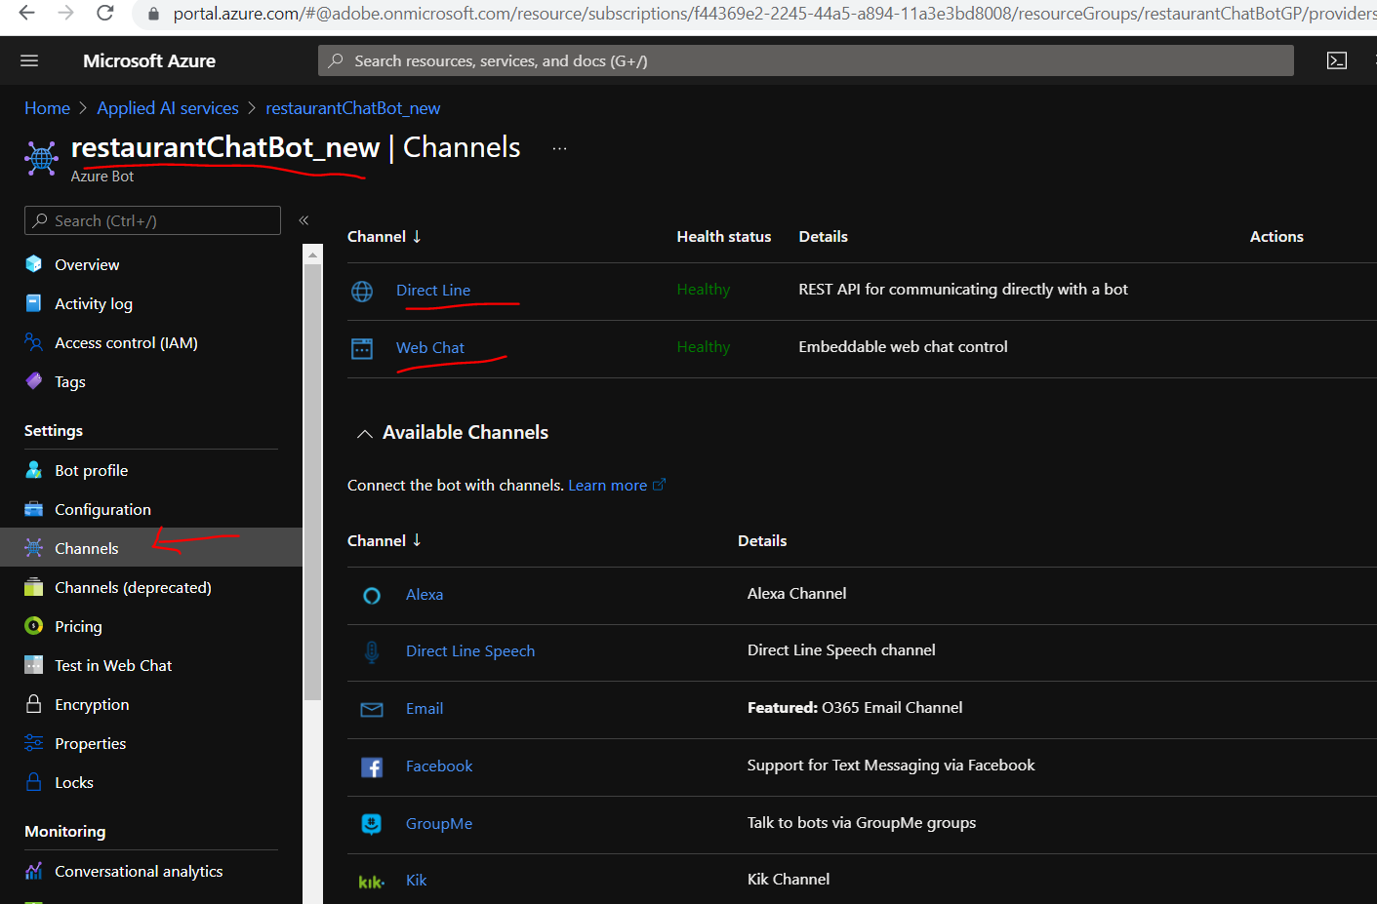

You can test the Bot on Azure itself:

First Enable **Direct Line Channel** as shown above

Once it is in running State, Choose “**Test In Web Chat**” option

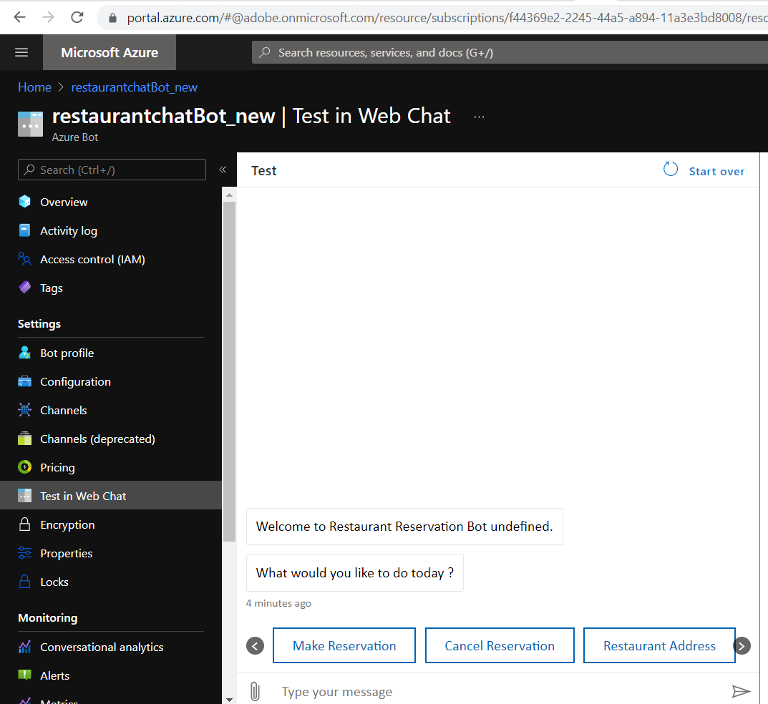

* **WebChat with Directline Channel**

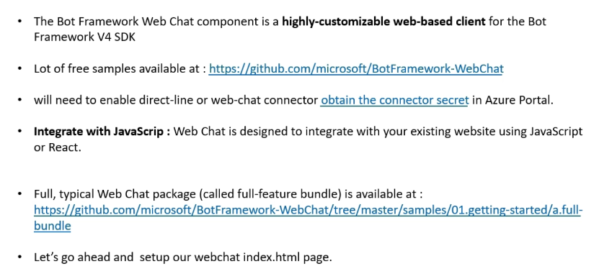

**Web chat samples:** <https://github.com/microsoft/BotFramework-WebChat/tree/main/samples>

We are going to use below sample to build our web chat : <https://github.com/microsoft/BotFramework-WebChat/tree/main/samples/01.getting-started/a.full-bundle>

We will take the **html code** from link above as mentioned to create our **webChat.html** file:

In the code we will replace the hard code the **token** like below:

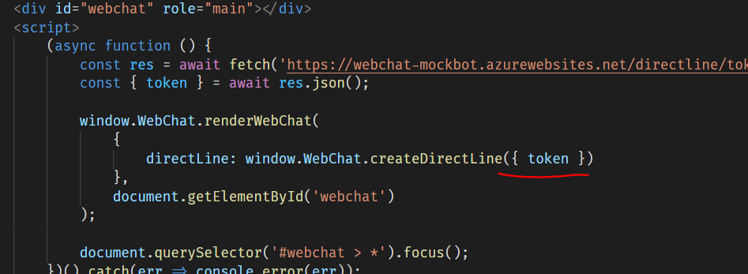

Above token will be changed to :

You can get the Direct line token from Azure portal like below:

Go to **Bot Services** -> Select your **bot** ->  **Channels ->** Go to **Direct Line**

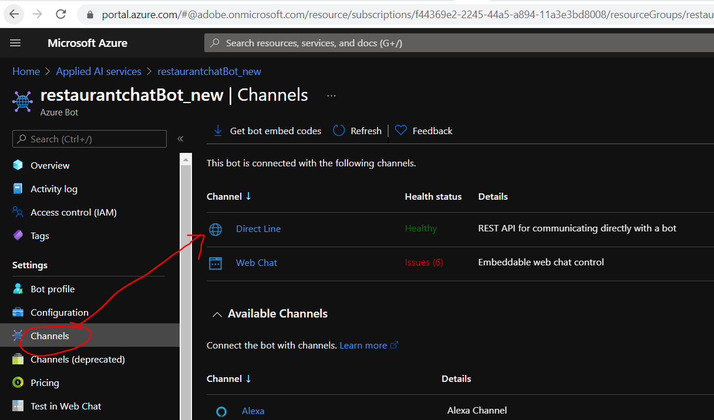

Copy any one of them:

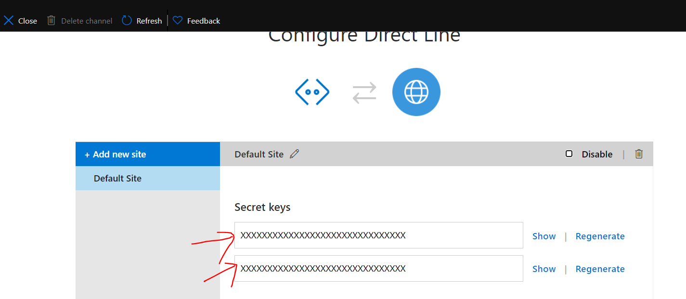

Now just open the .html file and you will see it working:

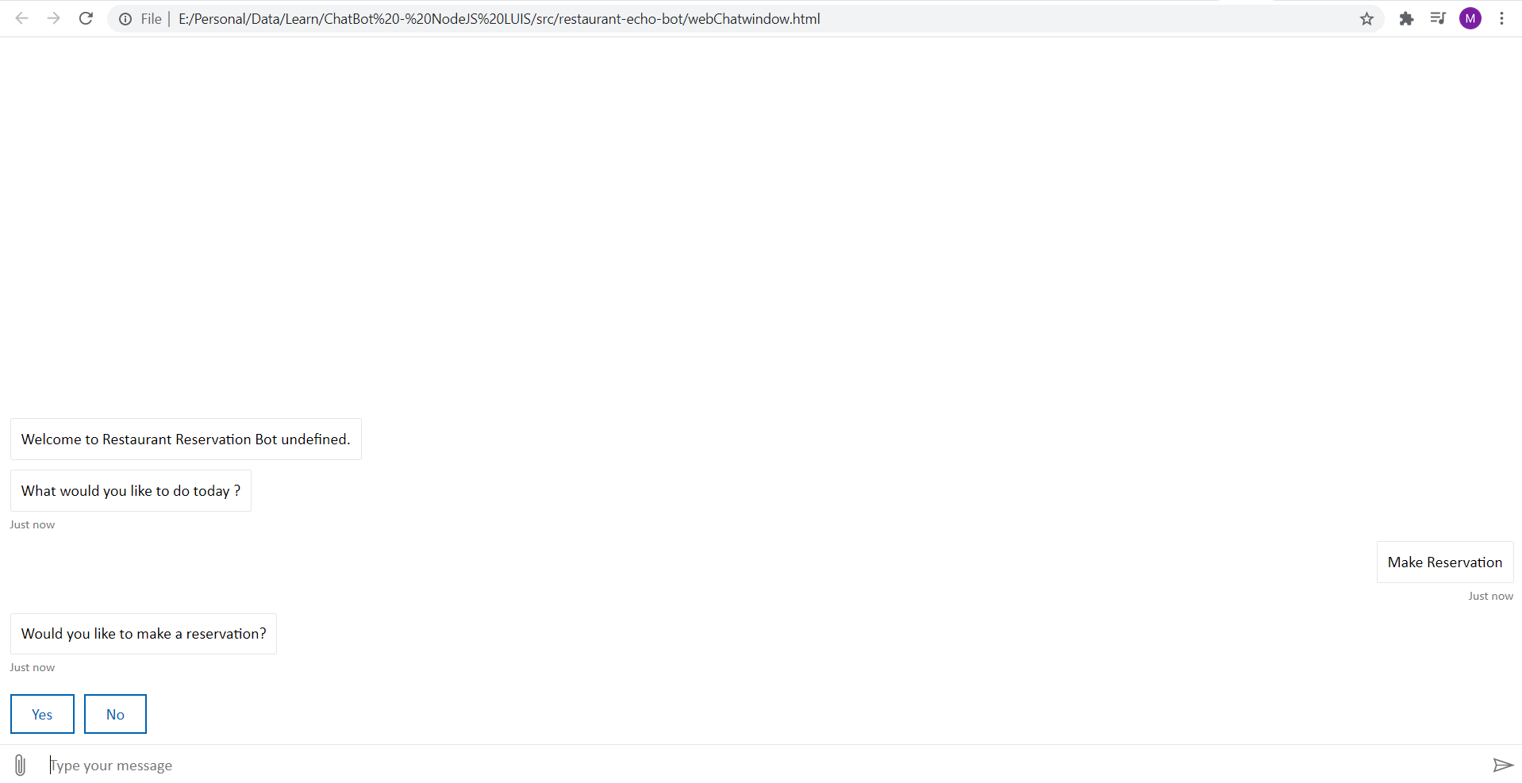

* **Connect Azure bot to Facebook messager**

1. Create a new **facebook page**

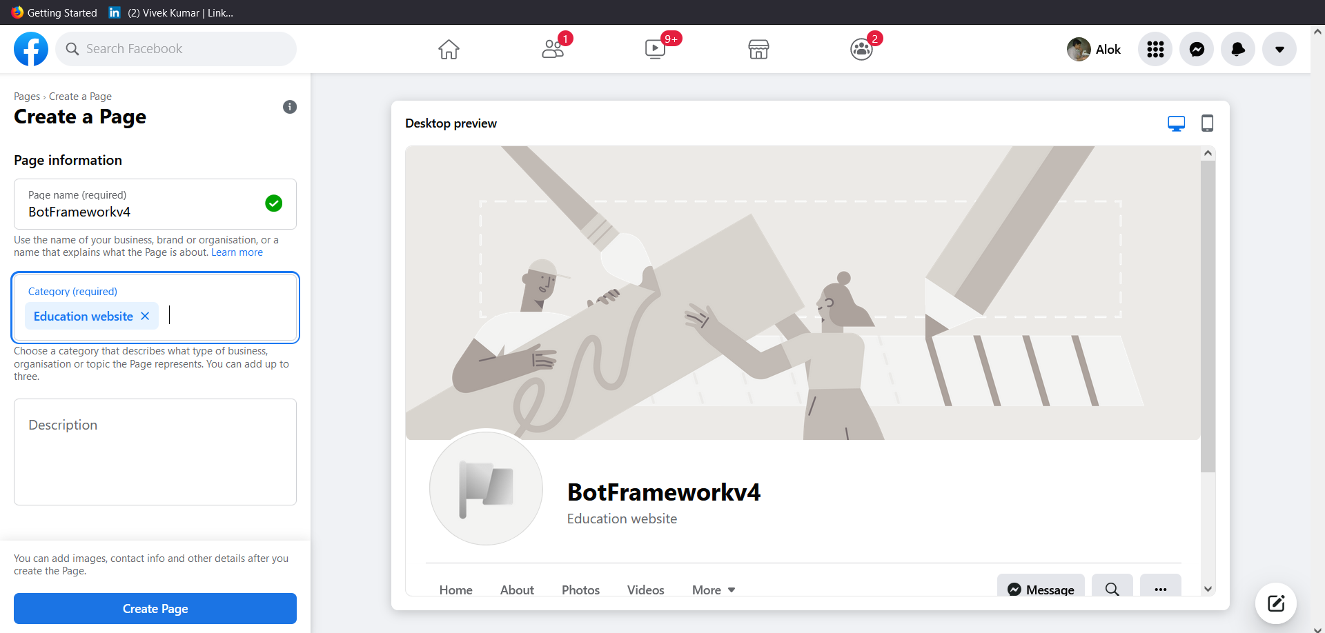

1. Create a Facebook app

Go to <https://developers.facebook.com/>

1. Copy the App id and Secret:

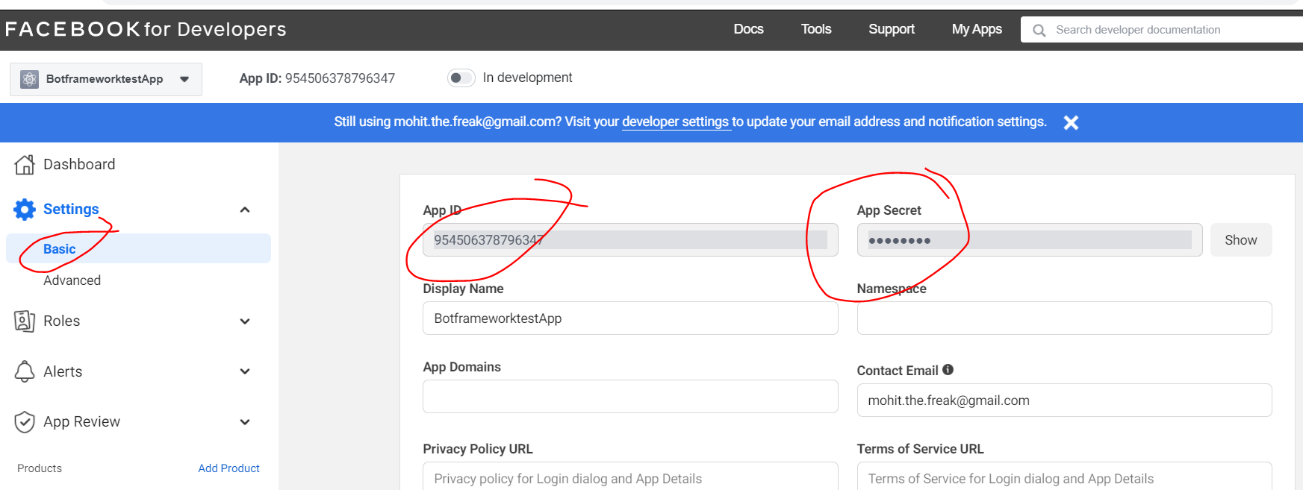

1. Allow API access

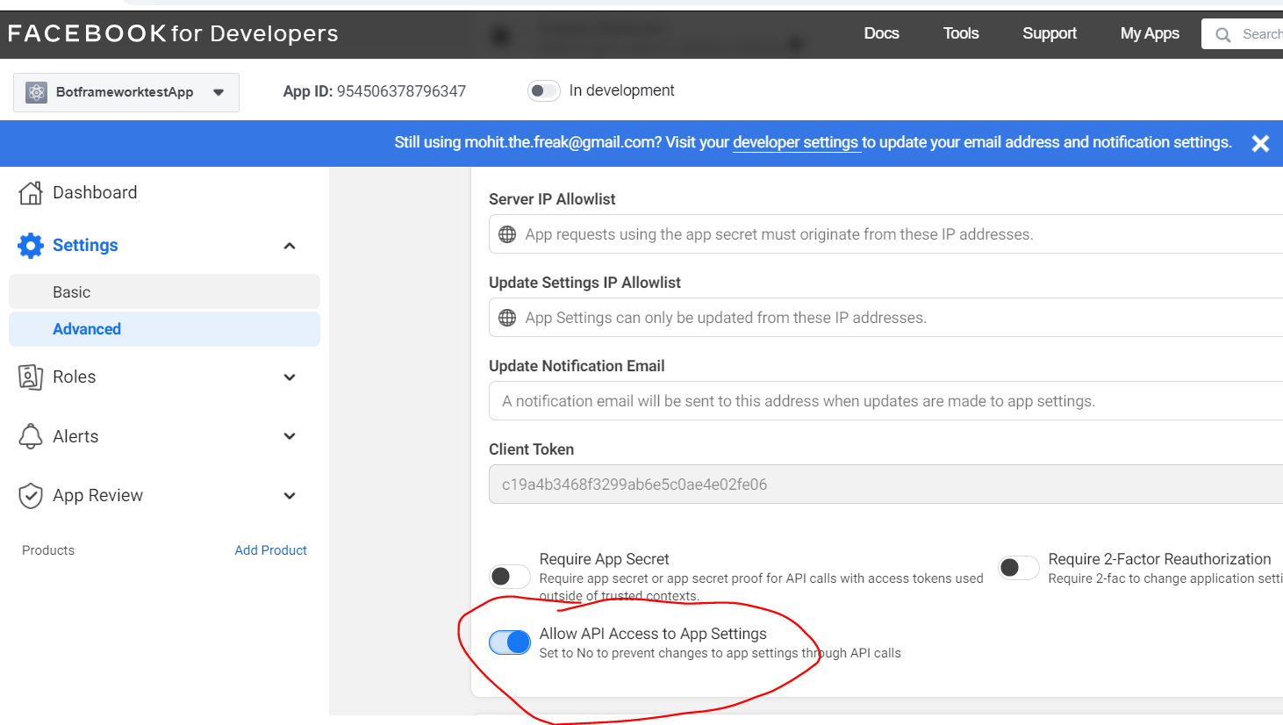

**Now facebook app and facebook page are ready**

1. Enable mesenger for the app

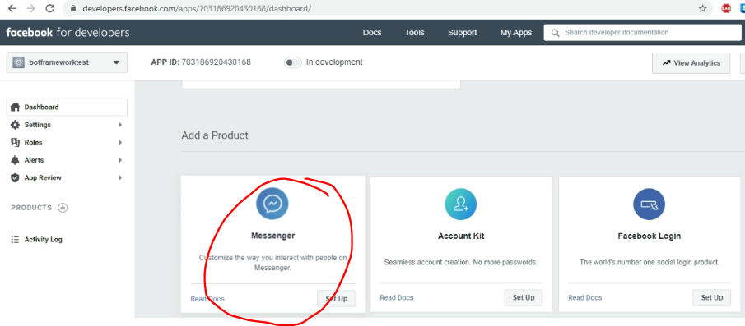

1. Create access token as below:

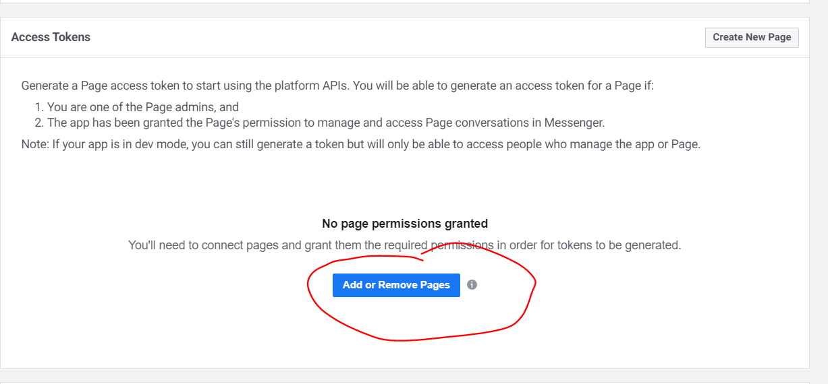

1. Select the page just created earlier

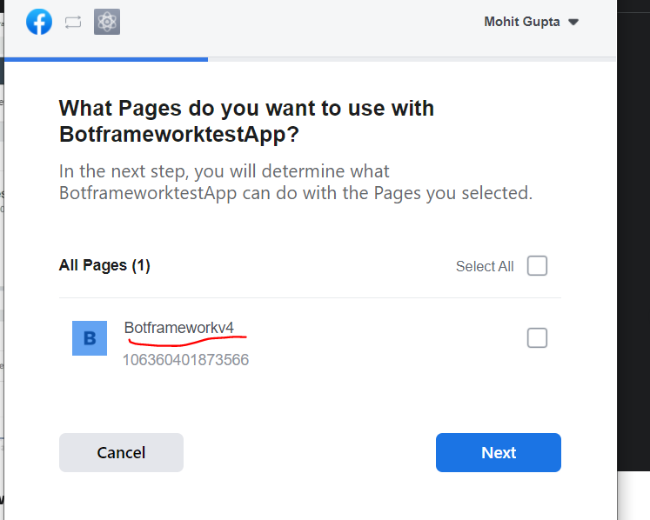

1. Genearet the token and also  **copy the Page id** for this app

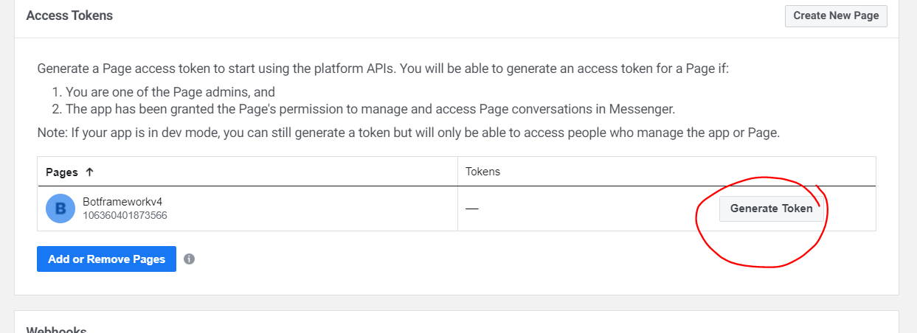

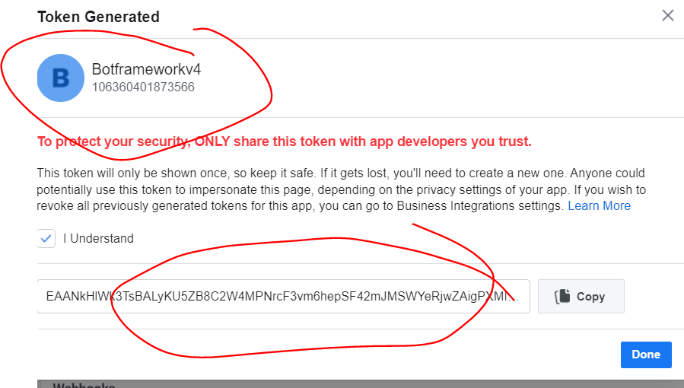

1. Enable web hooks in the facebook app:

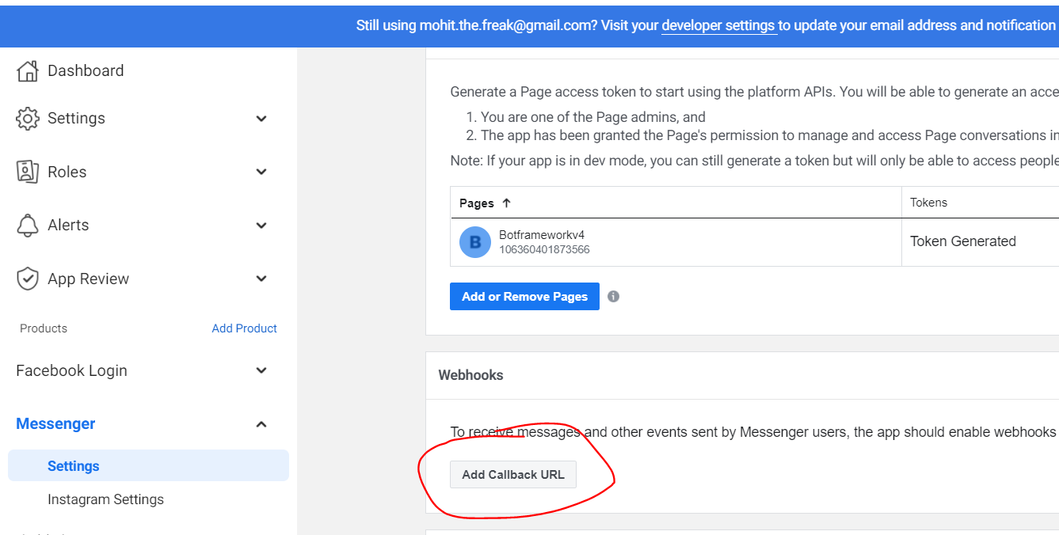

1. Give the callback URL . You can get the call back URL form Azure portal: Bot service-> Your Bot- > Channels- ore channels- > Click Facebook

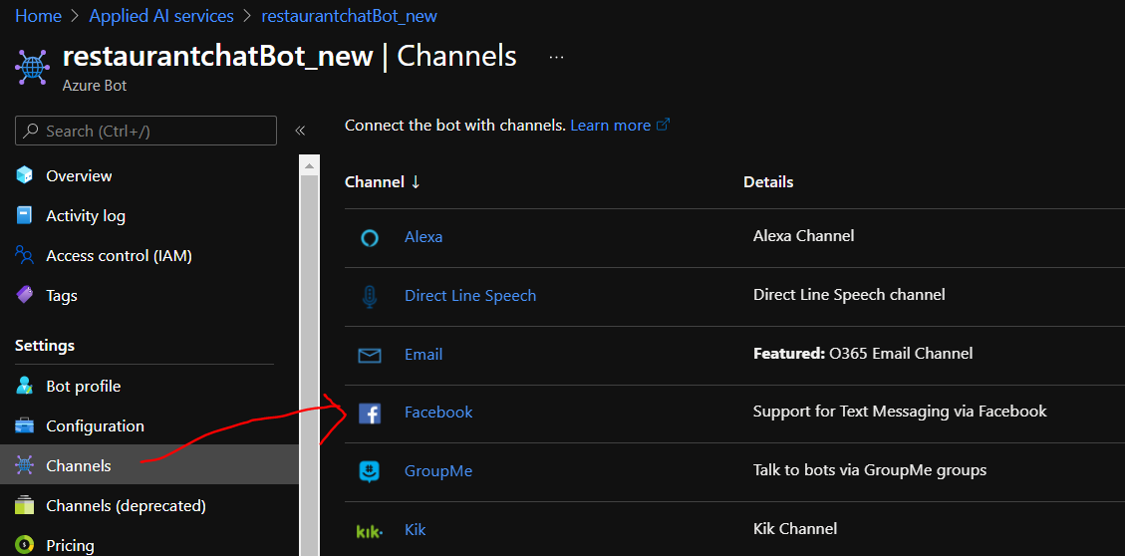

1. Proide the items genrated earlier i.e. Facebook AppId, App Secret, Page id and Access Token

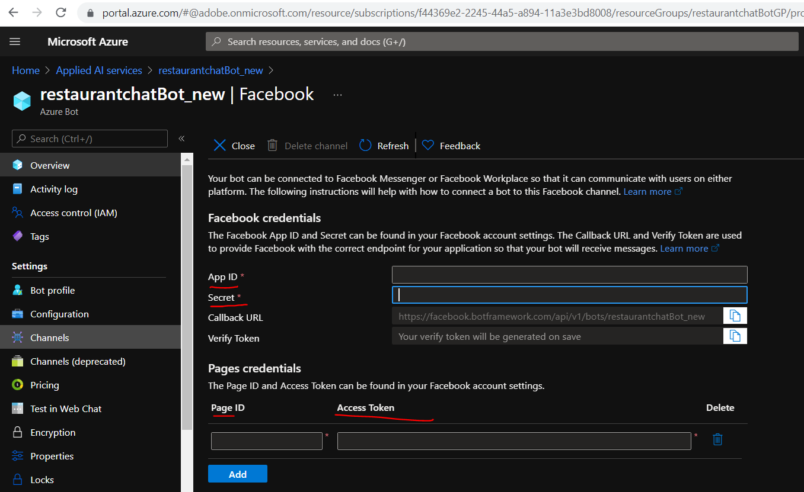

1. Once above details are saved, copy the Callback URL and Validity token

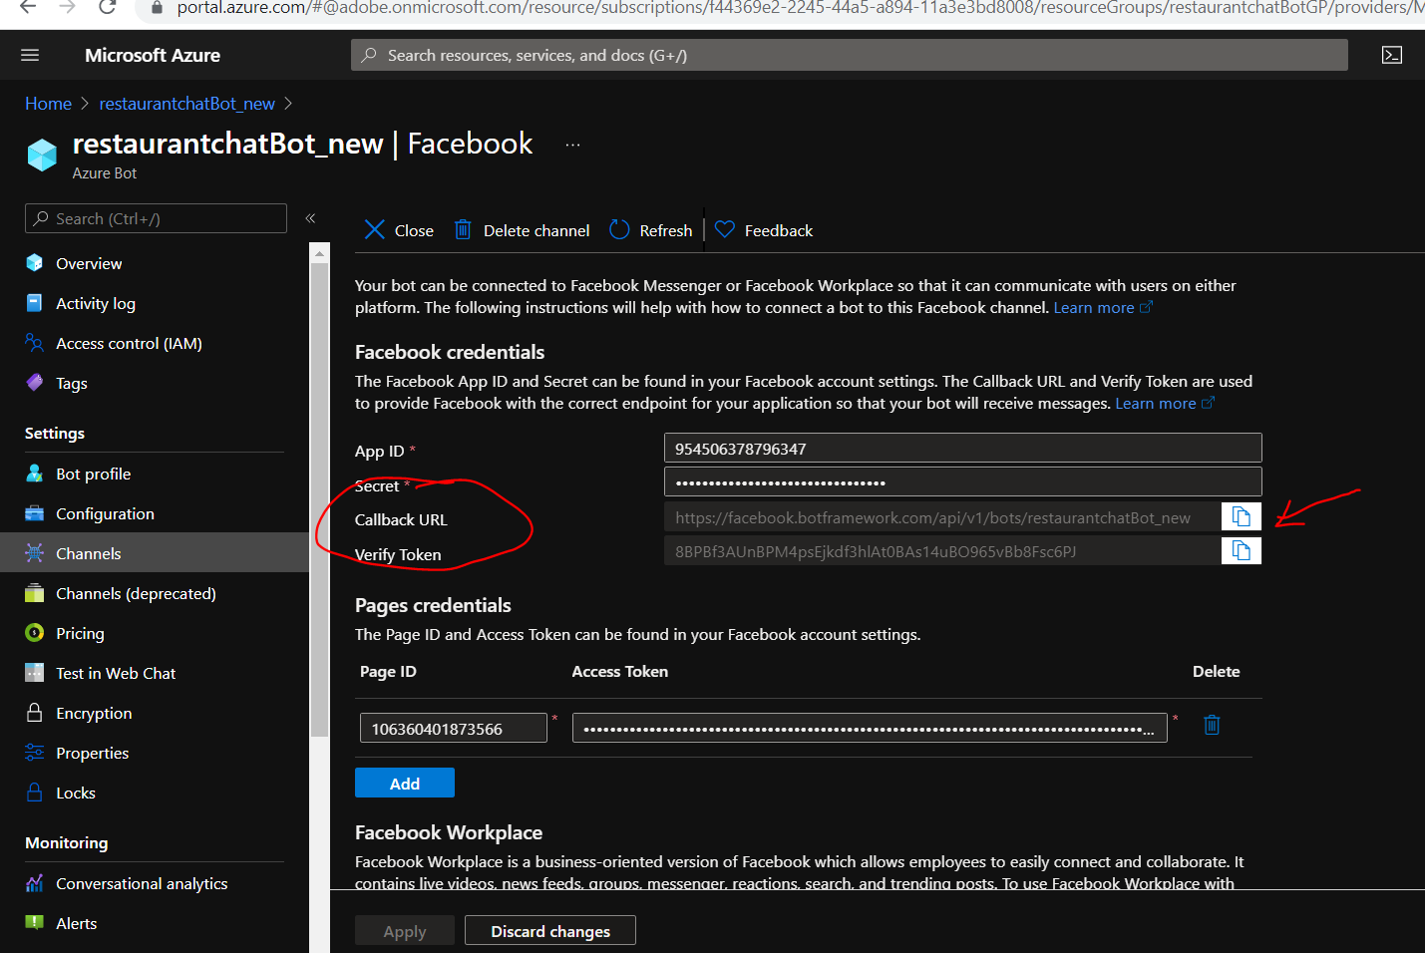

1. Paste the Callback URL and token as below:

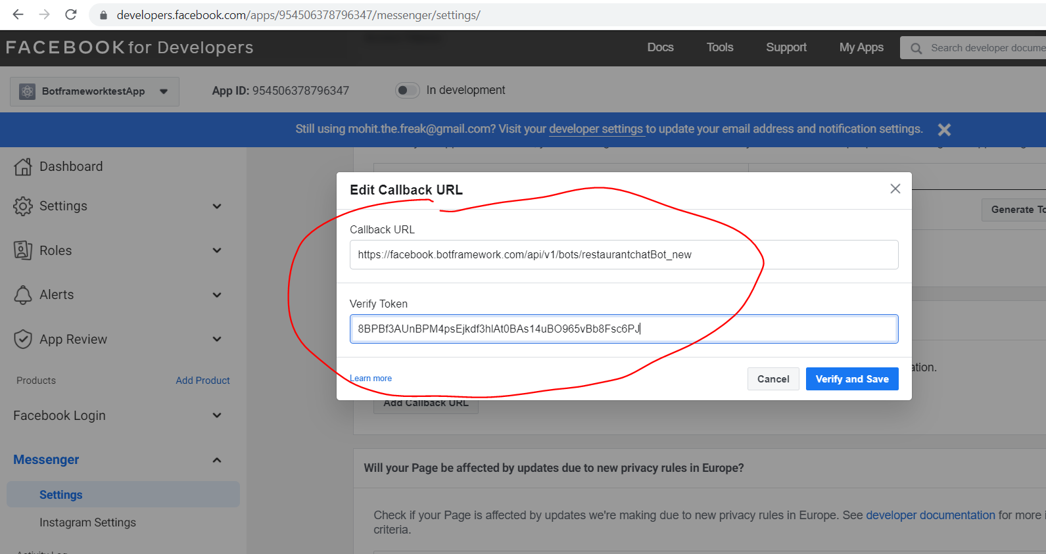

1. Add Subscriptions as below:

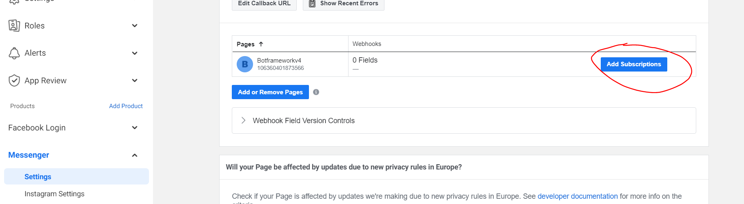

1. Select Subscriptions as below:

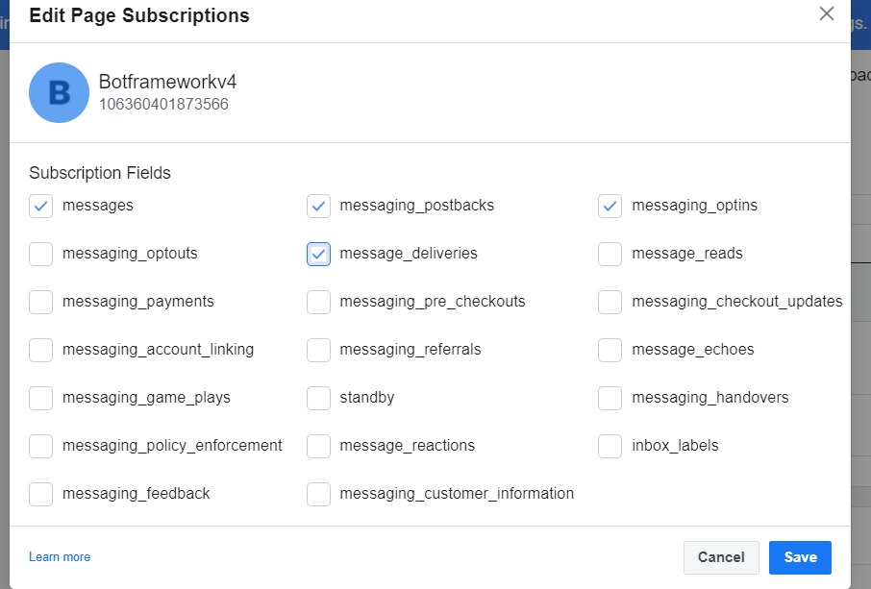

With the current configuraiton only **Developers and ADMIN** will be able to access azure hosted bot for testing purpose.

To make it available for public, You have to submit for **App Review by facebook**

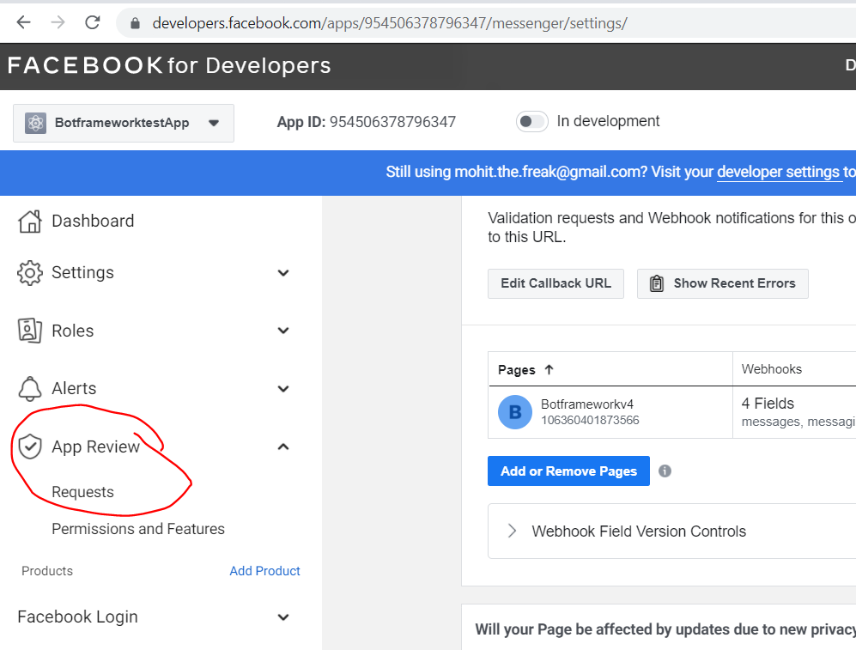

1. Next go to Facebook messager and select new message

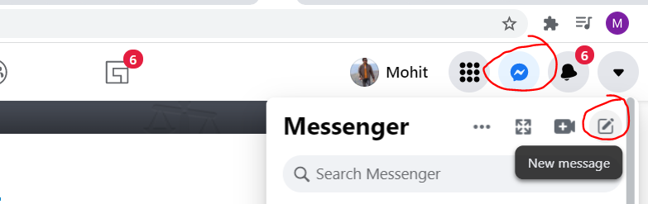

Selct your page and say ‘Hi’

